**Chapter 17**

**Time Series Analysis and Forecasting**

**Learning Objectives**

1. Be able to construct a time series plot and identify the underlying pattern in the data.

2. Understand how to measure forecast accuracy.

3. Be able to use smoothing techniques such as moving averages and exponential smoothing to forecast a time series with a horizontal pattern.

4. Know how simple linear regression and Holt’s linear exponential smoothing can be used to forecast a time series with a linear trend.

5. Be able to develop a quadratic trend equation and an exponential trend equation to forecast a time series with a curvilinear or nonlinear trend.

6. Know how to develop forecasts for a time series that has a seasonal pattern.

7. Know how time series decomposition can be used to separate or decompose a time series into season, trend, and irregular components.

8. Be able to deseasonalize a time series.

9. Know the definition of the following terms:

|  |  |
| --- | --- |
| time series | mean squared error |
| time series plot | mean absolute percentage error |
| horizontal pattern | moving average |
| stationary time series | weighted moving average |
| trend pattern | smoothing constant |
| seasonal pattern | time series decomposition |
| cyclical pattern | additive model |
| mean absolute error | multiplicative model |

**Solutions:**

1. The following table shows the calculations for parts (a), (b), and (c).

|  |  |  |  |  |  |  |  |
| --- | --- | --- | --- | --- | --- | --- | --- |
| **Week** | **Time Series Value** | **Forecast** | **Forecast Error** | **Absolute Value of Forecast Error** | **Squared Forecast Error** | **Percentage Error** | **Absolute Value of Percentage Error** |
| 1 | 18 |  |  |  |  |  |  |
| 2 | 13 | 18 | -5 | 5 | 25 | -38.46 | 38.46 |
| 3 | 16 | 13 | 3 | 3 | 9 | 18.75 | 18.75 |
| 4 | 11 | 16 | -5 | 5 | 25 | -45.45 | 45.45 |
| 5 | 17 | 11 | 6 | 6 | 36 | 35.29 | 35.29 |
| 6 | 14 | 17 | -3 | 3 | 9 | -21.43 | 21.43 |
|  |  |  | Totals | 22 | 104 | -51.30 | 159.38 |

a. MAE = 22/5 = 4.4

b. MSE = 104/5 = 20.8

c. MAPE = 159.38/5 = 31.88

d. Forecast for week 7 is 14

2. The following table shows the calculations for parts (a), (b), and (c).

|  |  |  |  |  |  |  |  |
| --- | --- | --- | --- | --- | --- | --- | --- |
| **Week** | **Time Series Value** | **Forecast** | **Forecast Error** | **Absolute Value of Forecast Error** | **Squared Forecast Error** | **Percentage Error** | **Absolute Value of Percentage Error** |
| 1 | 18 |  |  |  |  |  |  |
| 2 | 13 | 18.00 | -5.00 | 5.00 | 25.00 | -38.46 | 38.46 |
| 3 | 16 | 15.50 | 0.50 | 0.50 | 0.25 | 3.13 | 3.13 |
| 4 | 11 | 15.67 | -4.67 | 4.67 | 21.81 | -42.45 | 42.45 |
| 5 | 17 | 14.50 | 2.50 | 2.50 | 6.25 | 14.71 | 14.71 |
| 6 | 14 | 15.00 | -1.00 | 1.00 | 1.00 | -7.14 | 7.14 |
|  |  |  | Totals | 13.67 | 54.31 | -70.21 | 105.86 |

a. MAE = 13.67/5 = 2.73

b. MSE = 54.31/5 = 10.86

c. MAPE = 105.89/5 = 21.18

d. Forecast for week 7 is (18 + 13 + 16 + 11 + 17 + 14) / 6 = 14.83

3. The following table shows the measures of forecast error for both methods.

|  |  |  |
| --- | --- | --- |
|  | Exercise 1 | Exercise 2 |
| MAE | 4.40 | 2.73 |
| MSE | 20.80 | 10.86 |
| MAPE | 31.88 | 21.18 |

For each measure of forecast accuracy the average of all the historical data provided more accurate forecasts than simply using the most recent value.

4. a.

|  |  |  |  |  |
| --- | --- | --- | --- | --- |
| **Month** | **Time Series Value** | **Forecast** | **Forecast Error** | **Squared Forecast Error** |
| 1 | 24 |  |  |  |
| 2 | 13 | 24 | -11 | 121 |
| 3 | 20 | 13 | 7 | 49 |
| 4 | 12 | 20 | -8 | 64 |
| 5 | 19 | 12 | 7 | 49 |
| 6 | 23 | 19 | 4 | 16 |
| 7 | 15 | 23 | -8 | 64 |
|  |  |  | Total | 363 |

MSE = 363/6 = 60.5

Forecast for month 8 = 15

b.

|  |  |  |  |  |
| --- | --- | --- | --- | --- |
| **Week** | **Time Series Value** | **Forecast** | **Forecast Error** | **Squared Forecast Error** |
| 1 | 24 |  |  |  |
| 2 | 13 | 24.00 | -11.00 | 121.00 |
| 3 | 20 | 18.50 | 1.50 | 2.25 |
| 4 | 12 | 19.00 | -7.00 | 49.00 |
| 5 | 19 | 17.25 | 1.75 | 3.06 |
| 6 | 23 | 17.60 | 5.40 | 29.16 |
| 7 | 15 | 18.50 | -3.50 | 12.25 |
|  |  |  | Total | 216.72 |

MSE = 216.72/6 = 36.12

Forecast for month 8 = (24 + 13 + 20 + 12 + 19 + 23 + 15) / 7 = 18

c. The average of all the previous values is better because MSE is smaller.

5. a.

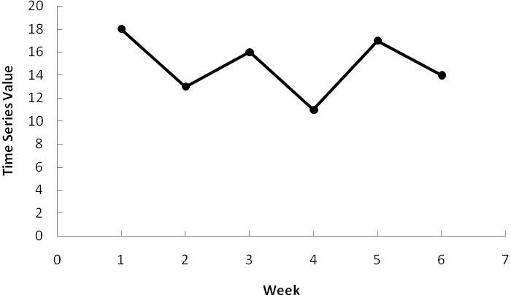

The data appear to follow a horizontal pattern.

b. Three-week moving average.

|  |  |  |  |  |
| --- | --- | --- | --- | --- |
| **Week** | **Time Series Value** | **Forecast** | **Forecast Error** | **Squared Forecast Error** |
| 1 | 18 |  |  |  |
| 2 | 13 |  |  |  |
| 3 | 16 |  |  |  |
| 4 | 11 | 15.67 | -4.67 | 21.78 |
| 5 | 17 | 13.33 | 3.67 | 13.44 |
| 6 | 14 | 14.67 | -0.67 | 0.44 |
|  |  |  | Total | 35.67 |

MSE = 35.67/3 = 11.89.

The forecast for week 7 = (11 + 17 + 14) / 3 = 14

c. Smoothing constant = .2

|  |  |  |  |  |
| --- | --- | --- | --- | --- |
| **Week** | **Time Series Value** | **Forecast** | **Forecast Error** | **Squared Forecast Error** |
| 1 | 18 |  |  |  |
| 2 | 13 | 18.00 | -5.00 | 25.00 |
| 3 | 16 | 17.00 | -1.00 | 1.00 |
| 4 | 11 | 16.80 | -5.80 | 33.64 |
| 5 | 17 | 15.64 | 1.36 | 1.85 |
| 6 | 14 | 15.91 | -1.91 | 3.66 |
|  |  |  | Total | 65.15 |

MSE = 65.15/5 = 13.03

The forecast for week 7 is .2(14) + (1 - .2)15.91 = 15.53

d. The three-week moving average provides a better forecast since it has a smaller MSE.

e. Smoothing constant = .4

|  |  |  |  |  |
| --- | --- | --- | --- | --- |
| **Week** | **Time Series Value** | **Forecast** | **Forecast Error** | **Squared Forecast Error** |
| 1 | 18 |  |  |  |
| 2 | 13 | 18.00 | -5.00 | 25.00 |
| 3 | 16 | 16.00 | 0.00 | 0.00 |
| 4 | 11 | 16.00 | -5.00 | 25.00 |
| 5 | 17 | 14.00 | 3.00 | 9.00 |
| 6 | 14 | 15.20 | -1.20 | 1.44 |
|  |  |  | Total | 60.44 |

MSE = 60.44/5 = 12.09

The exponential smoothing forecast using *α* = .4 provides a better forecast than the exponential smoothing forecast using *α* = .2 since it has a smaller MSE.

6. a.

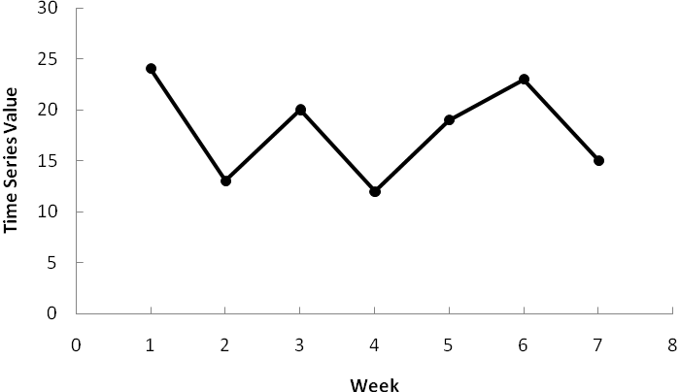

The data appear to follow a horizontal pattern.

Three-week moving average.

|  |  |  |  |  |
| --- | --- | --- | --- | --- |
| **Week** | **Time Series Value** | **Forecast** | **Forecast Error** | **Squared Forecast Error** |
| 1 | 24 |  |  |  |
| 2 | 13 |  |  |  |
| 3 | 20 |  |  |  |
| 4 | 12 | 19.00 | -7.00 | 49.00 |
| 5 | 19 | 15.00 | 4.00 | 16.00 |
| 6 | 23 | 17.00 | 6.00 | 36.00 |
| 7 | 15 | 18.00 | -3.00 | 9.00 |
|  |  |  | Total | 110.00 |

MSE = 110/4 = 27.5.

The forecast for week 8 = (19 + 23 + 15) / 3 = 19

b. Smoothing constant = .2

|  |  |  |  |  |
| --- | --- | --- | --- | --- |
| **Week** | **Time Series Value** | **Forecast** | **Forecast Error** | **Squared Forecast Error** |
| 1 | 24 |  |  |  |
| 2 | 13 | 24.00 | -11.00 | 121.00 |
| 3 | 20 | 21.80 | -1.80 | 3.24 |
| 4 | 12 | 21.44 | -9.44 | 89.11 |
| 5 | 19 | 19.55 | -0.55 | 0.30 |
| 6 | 23 | 19.44 | 3.56 | 12.66 |
| 7 | 15 | 20.15 | -5.15 | 26.56 |
|  |  |  | Total | 252.87 |

MSE = 252.87/6 = 42.15

The forecast for week 8 is .2(15) + (1 - .2)20.15 = 19.12

c. The three-week moving average provides a better forecast since it has a smaller MSE.

d. Smoothing constant = .4

|  |  |  |  |  |
| --- | --- | --- | --- | --- |
| **Week** | **Time Series Value** | **Forecast** | **Forecast Error** | **Squared Value of Forecast Error** |
| 1 | 24 |  |  |  |
| 2 | 13 | 24.00 | -11.00 | 121.00 |
| 3 | 20 | 19.60 | 0.40 | 0.16 |
| 4 | 12 | 19.76 | -7.76 | 60.22 |
| 5 | 19 | 16.66 | 2.34 | 5.49 |
| 6 | 23 | 17.59 | 5.41 | 29.23 |
| 7 | 15 | 19.76 | -4.76 | 22.62 |
|  |  |  | Total | 238.72 |

MSE = 238.72/6 = 39.79

The exponential smoothing forecast using *α* = .4 provides a better forecast than the exponential smoothing forecast using *α* = .2 since it has a smaller MSE.

7. a.

|  |  |  |  |  |  |
| --- | --- | --- | --- | --- | --- |
| **Week** | **Time-Series Value** | **4-Week Moving Average Forecast** | **(Error)2** | **5-Week Moving Average Forecast** | **(Error)2** |
| 1 | 17 |  |  |  |  |
| 2 | 21 |  |  |  |  |
| 3 | 19 |  |  |  |  |
| 4 | 23 |  |  |  |  |
| 5 | 18 | 20.00 | 4.00 |  |  |
| 6 | 16 | 20.25 | 18.06 | 19.60 | 12.96 |
| 7 | 20 | 19.00 | 1.00 | 19.40 | 0.36 |
| 8 | 18 | 19.25 | 1.56 | 19.20 | 1.44 |
| 9 | 22 | 18.00 | 16.00 | 19.00 | 9.00 |
| 10 | 20 | 19.00 | 1.00 | 18.80 | 1.44 |
| 11 | 15 | 20.00 | 25.00 | 19.20 | 17.64 |
| 12 | 22 | 18.75 | 10.56 | 19.00 | 9.00 |
|  |  | Totals | 77.18 |  | 51.84 |

b. MSE(4-Week) = 77.18 / 8 = 9.65

MSE(5-Week) = 51.84 / 7 = 7.41

c. For the limited data provided, the 5-week moving average provides the smallest MSE.

8. a.

|  |  |  |  |  |
| --- | --- | --- | --- | --- |
| **Week** | **Time-Series**  **Value** | **Weighted Moving Average Forecast** | **Forecast**  **Error** | **(Error)2** |
| 1 | 17 |  |  |  |
| 2 | 21 |  |  |  |
| 3 | 19 |  |  |  |
| 4 | 23 | 19.33 | 3.67 | 13.47 |
| 5 | 18 | 21.33 | -3.33 | 11.09 |
| 6 | 16 | 19.83 | -3.83 | 14.67 |
| 7 | 20 | 17.83 | 2.17 | 4.71 |
| 8 | 18 | 18.33 | -0.33 | 0.11 |
| 9 | 22 | 18.33 | 3.67 | 13.47 |
| 10 | 20 | 20.33 | -0.33 | 0.11 |
| 11 | 15 | 20.33 | -5.33 | 28.41 |
| 12 | 22 | 17.83 | 4.17 | 17.39 |
|  |  |  | Total | 103.43 |

b. MSE = 103.43 / 9 = 11.49

Prefer the unweighted moving average here; it has a smaller MSE.

c. You could always find a weighted moving average at least as good as the unweighted one. Actually the unweighted moving average is a special case of the weighted ones where the weights are equal.

9. The following tables show the calculations for ** = .1

|  |  |  |  |  |  |  |  |
| --- | --- | --- | --- | --- | --- | --- | --- |
| **Week** | **Time Series Value** | **Forecast** | **Forecast Error** | **Absolute Value of Forecast Error** | **Squared Forecast Error** | **Percentage Error** | **Absolute Value of Percentage Error** |
| 1 | 17 |  |  |  |  |  |  |
| 2 | 21 | 17.00 | 4.00 | 4.00 | 16.00 | 19.05 | 19.05 |
| 3 | 19 | 17.40 | 1.60 | 1.60 | 2.56 | 8.42 | 8.42 |
| 4 | 23 | 17.56 | 5.44 | 5.44 | 29.59 | 23.65 | 23.65 |
| 5 | 18 | 18.10 | -0.10 | 0.10 | 0.01 | -0.56 | 0.56 |
| 6 | 16 | 18.09 | -2.09 | 2.09 | 4.37 | -13.06 | 13.06 |
| 7 | 20 | 17.88 | 2.12 | 2.12 | 4.49 | 10.60 | 10.60 |
| 8 | 18 | 18.10 | -0.10 | 0.10 | 0.01 | -0.56 | 0.56 |
| 9 | 22 | 18.09 | 3.91 | 3.91 | 15.29 | 17.77 | 17.77 |
| 10 | 20 | 18.48 | 1.52 | 1.52 | 2.31 | 7.60 | 7.60 |
| 11 | 15 | 18.63 | -3.63 | 3.63 | 13.18 | -24.20 | 24.20 |
| 12 | 22 | 18.27 | 3.73 | 3.73 | 13.91 | 16.95 | 16.95 |
|  |  |  | Totals | 28.24 | 101.72 | 65.67 | 142.42 |

The following tables show the calculations for ** = .2

|  |  |  |  |  |  |  |  |
| --- | --- | --- | --- | --- | --- | --- | --- |
| **Week** | **Time Series Value** | **Forecast** | **Forecast Error** | **Absolute Value of Forecast Error** | **Squared Forecast Error** | **Percentage Error** | **Absolute Value of Percentage Error** |
| 1 | 17 |  |  |  |  |  |  |
| 2 | 21 | 17.00 | 4.00 | 4.00 | 16.00 | 19.05 | 19.05 |
| 3 | 19 | 17.80 | 1.20 | 1.20 | 1.44 | 6.32 | 6.32 |
| 4 | 23 | 18.04 | 4.96 | 4.96 | 24.60 | 21.57 | 21.57 |
| 5 | 18 | 19.03 | -1.03 | 1.03 | 1.06 | -5.72 | 5.72 |
| 6 | 16 | 18.83 | -2.83 | 2.83 | 8.01 | -17.69 | 17.69 |
| 7 | 20 | 18.26 | 1.74 | 1.74 | 3.03 | 8.70 | 8.70 |
| 8 | 18 | 18.61 | -0.61 | 0.61 | 0.37 | -3.39 | 3.39 |
| 9 | 22 | 18.49 | 3.51 | 3.51 | 12.32 | 15.95 | 15.95 |
| 10 | 20 | 19.19 | 0.81 | 0.81 | 0.66 | 4.05 | 4.05 |
| 11 | 15 | 19.35 | -4.35 | 4.35 | 18.92 | -29.00 | 29.00 |
| 12 | 22 | 18.48 | 3.52 | 3.52 | 12.39 | 16.00 | 16.00 |
|  |  |  | Totals | 28.56 | 98.80 | 35.84 | 147.44 |

a. MSE for ** = .1 = 101.72/11 = 9.25

MSE for ** = .2 = 98.80/11 = 8.98

** = .2 provides more accurate forecasts based upon MSE

b. MAE for ** = .1 = 28.24/11 = 2.57

MAE for ** = .2 = 28.56/11 = 2.60

 = .1 provides more accurate forecasts based upon MAE; but, they are very close.

c. MAPE for ** = .1 = 142.42/11 = 12.95%

MAPE for ** = .2 = 147.44/11 = 13.40%

** = .1 provides more accurate forecasts based upon MAPE

10. a. *F*13 = .2*Y*12 + .16*Y*11 + .64(.2*Y*10 + .8*F*10) = .2*Y*12 + .16*Y*11 + .128*Y*10 + .512*F*10

*F*13 = .2*Y*12 + .16*Y*11 + .128*Y*10 + .512(.2*Y*9 + .8*F*9) = .2*Y*12 + .16*Y*11 + .128*Y*10 + .1024*Y*9 + .4096*F*9

*F*13 = .2*Y*12 + .16*Y*11 + .128*Y*10 + .1024*Y*9 + .4096(.2*Y*8 + .8*F*8) = .2*Y*12 + .16*Y*11 + .128*Y*10 + .1024*Y*9 + .08192*Y*8 + .32768*F*8

b. The more recent data receives the greater weight or importance in determining the forecast. The moving averages method weights the last *n* data values equally in determining the forecast.

11. a.

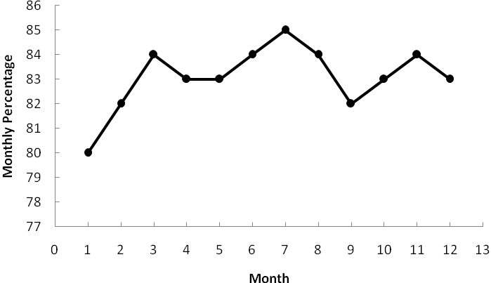

The first two time series values may be an indication that the time series has shifted to a new higher level, as shown by the remainig 10 values. But, overall, the time series plot exhibits a horizontal pattern.

b.

|  |  |  |  |  |  |
| --- | --- | --- | --- | --- | --- |
| **Month** | ***Y*t** | **3-Month Moving Averages Forecast** | **(Error)2** | ***α* = 2**  **Forecast** | **(Error)2** |
| 1 | 80 |  |  |  |  |
| 2 | 82 |  |  | 80.00 | 4.00 |
| 3 | 84 |  |  | 80.40 | 12.96 |
| 4 | 83 | 82.00 | 1.00 | 81.12 | 3.53 |
| 5 | 83 | 83.00 | 0.00 | 81.50 | 2.25 |
| 6 | 84 | 83.33 | 0.45 | 81.80 | 4.84 |
| 7 | 85 | 83.33 | 2.79 | 82.24 | 7.62 |
| 8 | 84 | 84.00 | 0.00 | 82.79 | 1.46 |
| 9 | 82 | 84.33 | 5.43 | 83.03 | 1.06 |
| 10 | 83 | 83.67 | 0.45 | 82.83 | 0.03 |
| 11 | 84 | 83.00 | 1.00 | 82.86 | 1.30 |
| 12 | 83 | 83.00 | 0.00 | 83.09 | 0.01 |
|  |  | Totals | 11.12 |  | 39.06 |

MSE(3-Month) = 11.12 / 9 = 1.24

MSE(*α* = .2) = 39.06 / 11 = 3.55

A 3-month moving average provides the most accurate forecast using MSE

c. 3-month moving average forecast = (83 + 84 + 83) / 3 = 83.3

12. a.

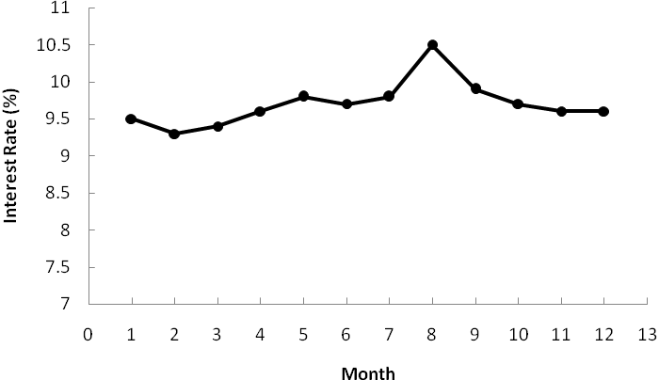

The data appear to follow a horizontal pattern.

b.

|  |  |  |  |  |  |
| --- | --- | --- | --- | --- | --- |
| **Month** | **Time-Series Value** | **3-Month Moving Average Forecast** | **(Error)2** | **4-Month Moving Average Forecast** | **(Error)2** |
| 1 | 9.5 |  |  |  |  |
| 2 | 9.3 |  |  |  |  |
| 3 | 9.4 |  |  |  |  |
| 4 | 9.6 | 9.40 | 0.04 |  |  |
| 5 | 9.8 | 9.43 | 0.14 | 9.45 | 0.12 |
| 6 | 9.7 | 9.60 | 0.01 | 9.53 | 0.03 |
| 7 | 9.8 | 9.70 | 0.01 | 9.63 | 0.03 |
| 8 | 10.5 | 9.77 | 0.53 | 9.73 | 0.59 |
| 9 | 9.9 | 10.00 | 0.01 | 9.95 | 0.00 |
| 10 | 9.7 | 10.07 | 0.14 | 9.98 | 0.08 |
| 11 | 9.6 | 10.03 | 0.18 | 9.97 | 0.14 |
| 12 | 9.6 | 9.73 | 0.02 | 9.92 | 0.10 |
|  |  | Totals | 1.08 |  | 1.09 |

MSE(3-Month) = 1.08 / 9 = .12

MSE(4-Month) = 1.09 / 8 = .14

Use 3-Month moving averages.

c. Forecast = (9.7 + 9.6 + 9.6) / 3 = 9.63

13. a.

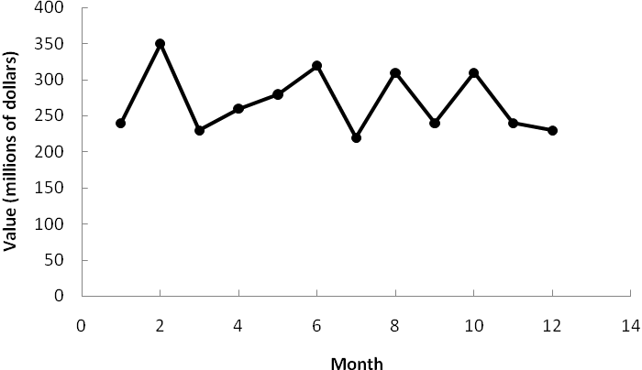

The data appear to follow a horizontal pattern.

b.

|  |  |  |  |  |  |
| --- | --- | --- | --- | --- | --- |
| **Month** | **Time-Series Value** | **3-Month Moving Average Forecast** | **(Error)2** | ***α* = .2**  **Forecast** | **(Error)2** |
| 1 | 240 |  |  |  |  |
| 2 | 350 |  |  | 240.00 | 12100.00 |
| 3 | 230 |  |  | 262.00 | 1024.00 |
| 4 | 260 | 273.33 | 177.69 | 255.60 | 19.36 |
| 5 | 280 | 280.00 | 0.00 | 256.48 | 553.19 |
| 6 | 320 | 256.67 | 4010.69 | 261.18 | 3459.79 |
| 7 | 220 | 286.67 | 4444.89 | 272.95 | 2803.70 |
| 8 | 310 | 273.33 | 1344.69 | 262.36 | 2269.57 |
| 9 | 240 | 283.33 | 1877.49 | 271.89 | 1016.97 |
| 10 | 310 | 256.67 | 2844.09 | 265.51 | 1979.36 |
| 11 | 240 | 286.67 | 2178.09 | 274.41 | 1184.05 |
| 12 | 230 | 263.33 | 1110.89 | 267.53 | 1408.50 |
|  |  | Totals | 17,988.52 |  | 27,818.49 |

MSE(3-Month) = 17,988.52 / 9 = 1998.72

MSE(*α* = .2) = 27,818.49 / 11 = 2528.95

Based on the above MSE values, the 3-month moving averages appears better. However, exponential smoothing was penalized by including month 2 which was difficult for any method to forecast. Using only the errors for months 4 to 12, the MSE for exponential smoothing is:

MSE(*α* = .2) = 14,694.49 / 9 = 1632.72

Thus, exponential smoothing was better considering months 4 to 12.

c. Using exponential smoothing,

*F*13 = *α* *Y*12 + (1 - *α*)*F*12  = .20(230) + .80(267.53) = 260

14. a.

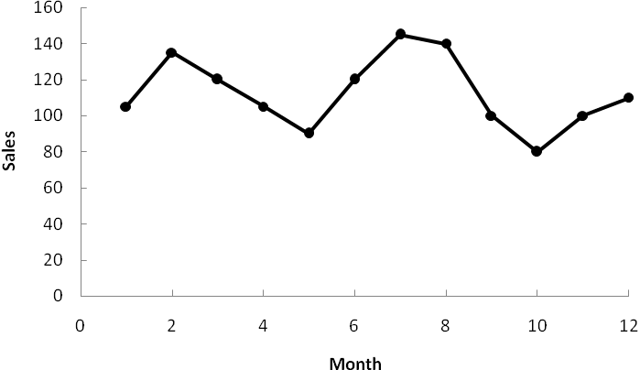

The data appear to follow a horizontal pattern.

b. Smoothing constant = .3.

|  |  |  |  |  |
| --- | --- | --- | --- | --- |
| **Month *t*** | **Time-Series Value**  ***Y*t** | **Forecast *F*t** | **Forecast Error**  ***Y*t - *F*t** | **Squared Error**  **(*Y*t - *F*t)2** |
| 1 | 105 |  |  |  |
| 2 | 135 | 105.00 | 30.00 | 900.00 |
| 3 | 120 | 114.00 | 6.00 | 36.00 |
| 4 | 105 | 115.80 | -10.80 | 116.64 |
| 5 | 90 | 112.56 | -22.56 | 508.95 |
| 6 | 120 | 105.79 | 14.21 | 201.92 |
| 7 | 145 | 110.05 | 34.95 | 1221.50 |
| 8 | 140 | 120.54 | 19.46 | 378.69 |
| 9 | 100 | 126.38 | -26.38 | 695.90 |
| 10 | 80 | 118.46 | -38.46 | 1479.17 |
| 11 | 100 | 106.92 | -6.92 | 47.89 |
| 12 | 110 | 104.85 | 5.15 | 26.52 |
|  |  |  | Total | 5613.18 |

MSE = 5613.18 / 11 = 510.29

Forecast for month 13: *F*13 = .3(110) + .7(104.85) = 106.4

c. Smoothing constant = .5

|  |  |  |  |  |
| --- | --- | --- | --- | --- |
| **Month *t*** | **Time-Series Value**  ***Y*t** | **Forecast *F*t** | **Forecast Error**  ***Y*t - *F*t** | **Squared Error**  **(*Y*t - *F*t)2** |
| 1 | 105 |  |  |  |
| 2 | 135 | 105 | 30.00 | 900.00 |
| 3 | 120 | 120 | 0.00 | 0.00 |
| 4 | 105 | 120 | -15.00 | 225.00 |
| 5 | 90 | 112.50 | -22.50 | 506.25 |
| 6 | 120 | 101.25 | 18.75 | 351.56 |
| 7 | 145 | 110.63 | 34.37 | 1181.30 |
| 8 | 140 | 127.81 | 12.19 | 148.60 |
| 9 | 100 | 133.91 | -33.91 | 1149.89 |
| 10 | 80 | 116.95 | -36.95 | 1365.30 |
| 11 | 100 | 98.48 | 1.52 | 2.31 |
| 12 | 110 | 99.24 | 10.76 | 115.78 |
|  |  |  |  | 5945.99 |

MSE = 5945.99 / 11 = 540.55

Forecast for month 13: *F*13 = .5(110) + .5(99.24) = 104.62

Conclusion: a smoothing constant of .3 is better than a smoothing constant of .5 since the MSE is less for 0.3.

15. a.

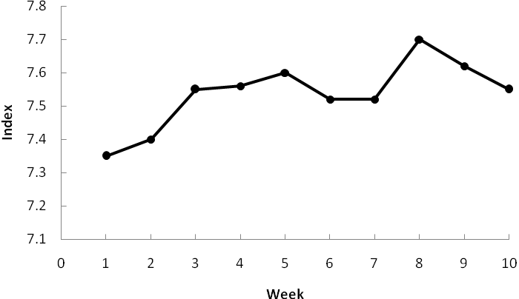

You might think the time series plot shown above exhibits some trend. But, this is simply due to the fact that the smallest value on the vertical axis is 7.1, as shown by the following version of the plot.

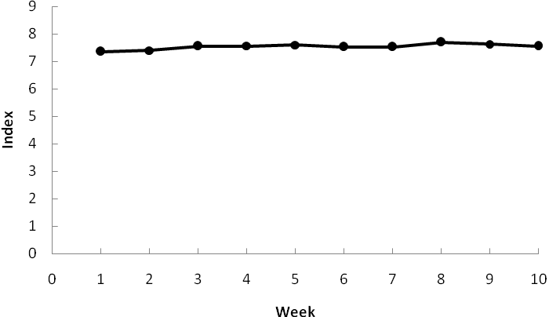

In other words, the time series plot shows an underlying horizontal pattern.

b/c.

|  |  |  |  |  |  |
| --- | --- | --- | --- | --- | --- |
| **Week** | **Time-Series Value** | ***α* = .2**  **Forecast** | **(Error)2** | ***α* = .3**  **Forecast** | **(Error)2** |
| 1 | 7.35 |  |  |  |  |
| 2 | 7.40 | 7.35 | .0025 | 7.35 | .0025 |
| 3 | 7.55 | 7.36 | .0361 | 7.36 | .0361 |
| 4 | 7.56 | 7.40 | .0256 | 7.42 | .0196 |
| 5 | 7.60 | 7.43 | .0289 | 7.46 | .0196 |
| 6 | 7.52 | 7.46 | .0036 | 7.50 | .0004 |
| 7 | 7.52 | 7.48 | .0016 | 7.51 | .0001 |
| 8 | 7.70 | 7.48 | .0484 | 7.51 | .0361 |
| 9 | 7.62 | 7.53 | .0081 | 7.57 | .0025 |
| 10 | 7.55 | 7.55 | .0000 | 7.58 | .0009 |
|  |  |  | .1548 |  | .1178 |

d. MSE(*α* = .2) = .1548 / 9 = .0172

MSE(*α* = .3) = .1178 / 9 = .0131

Use *α* = .3.

*F*11 = .3*Y*10 + .7*F*10 = .3(7.55) + .7(7.58) = 7.57

16. a.

The time series plot exhibits a trend pattern. Although the recession of 2008 led to a downturn in prices, the median price rose form 2010 to 2011.

b. The methods disucssed in this section are only applicable for a time series that has a horizontal pattern. Because the time series plot exhibits a trend pattern, the methods disucssed in this section are not appropriate.

c. In 2003 the median price was $189,500, and in 2004 the median price was $222,300. So, it appears that the time series shifted to a new level in 2004. The time series plot using just the data for 2004 and later follows.

This time series plot exhibits a horizontal pattern. Therefore, the methods discussed in this section are approporiate.

17. a.

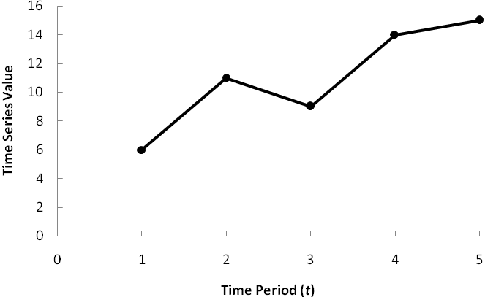

The time series plot shows a linear trend.

b. 









c. 

18. Holt’s linear exponential smoothing using *α* = .3 and *β* = .5

|  |  |  |  |  |
| --- | --- | --- | --- | --- |
| ***t*** | **Value** | **Estimated Level** | **Estimated Trend** | **Forecast** |
| 1 | 6 | 6.00 | 5.00 |  |
| 2 | 11 | 11.00 | 5.00 | 11.00 |
| 3 | 9 | 13.90 | 3.95 | 16.00 |
| 4 | 14 | 16.70 | 3.37 | 17.85 |
| 5 | 15 | 18.55 | 2.61 | 20.07 |

Forecast for week 6 = 18.55 + 2.61 = 21.16

19. a.

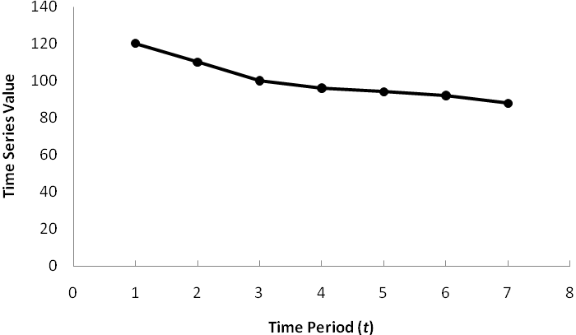

The time series plot shows a linear trend.

b. 









c. 

20. a.

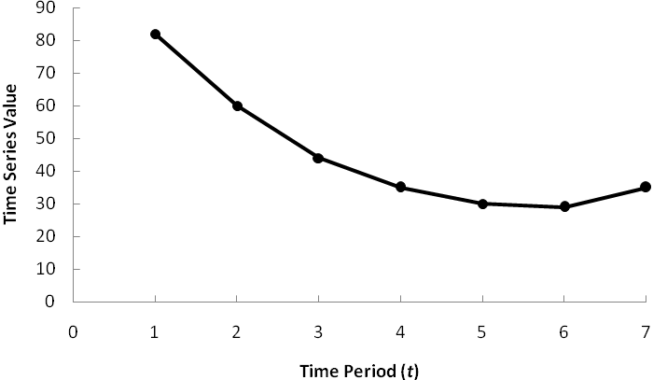

The time series plot exhibits a curvilinear trend.

b. Using Minitab, the linear trend equation is =107.857 -28.9881 *t* +2.65476 

c. =107.857 -28.9881(8) +2.65476= 45.86

21. a.

b. 







c. 

Forecast for 2012 is $9.34 billion

22. a.

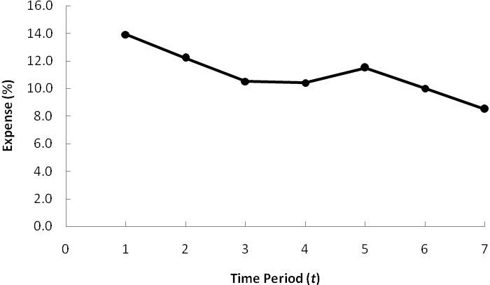

The time series plot shows a downward linear trend

b. 









c. 2013 corresponds to time period *t* = 8. 

d. If SCF can continue to decrease the percentage of funds spent on administrative and fund-raising by .7% per year, the forecast of expenses for 2018 is 4.70%.

23. a.

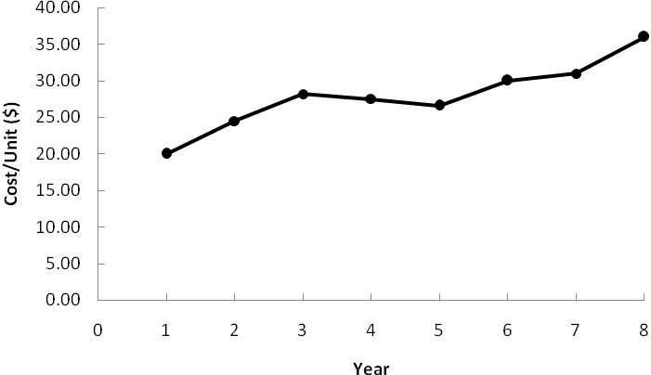

The time series plot shows an upward linear trend

b. 









c. The average cost/unit has been increasing by approximately $1.77 per year.

d. 

24. a.

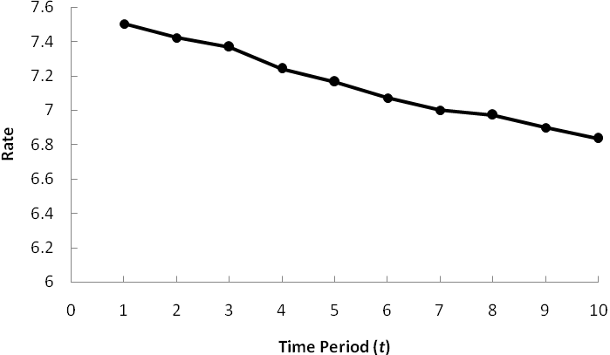

The time series plot shows a linear trend.

b. Using Minitab, the linear trend equation is

c. A forecast for August corresponds to *t* = 11.



d. Given the uncertainty in global market conditions, making a prediction for December using only time is not recommended.

25. a.

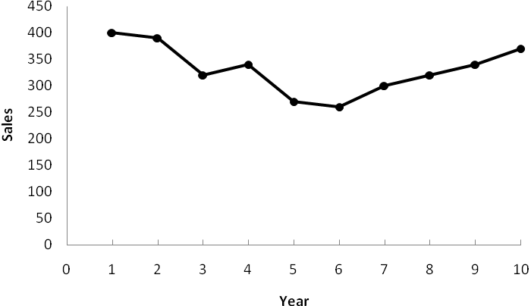

A linear trend is not appropriate.

b. The following output shows the results of using Minitab’s Time Series – Trend Analysis procedure to fit a quadratic trend to the time series.

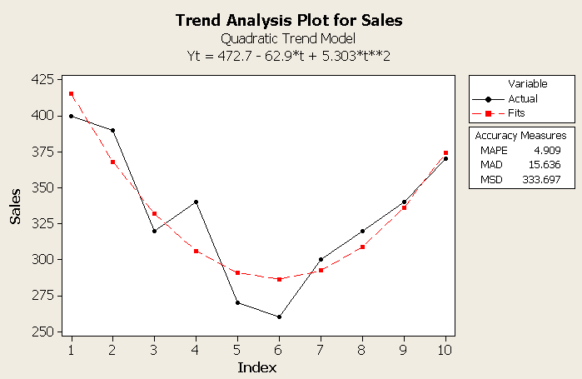

The quadratic trend equation is 

c. 

d. Sales appear to have bottomed-out in year 6 and appear to be increasing in a linear fashion for years 6 – 10. So, another alternative would be to use the data for years 6 – 10 (or 5 -10) to develop a linear trend equation to forecast sales in year 11.

26. a.

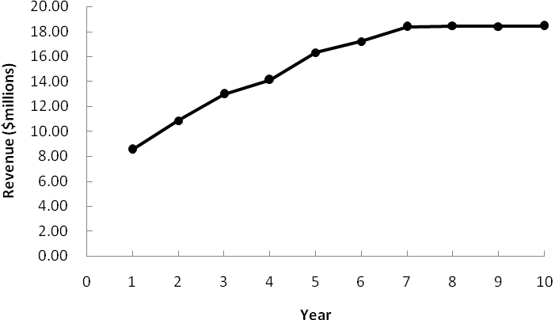

A linear trend is not appropriate.

b. The following output shows the results of using Minitab’s Time Series – Trend Analysis procedure to fit a quadratic trend to the time series.

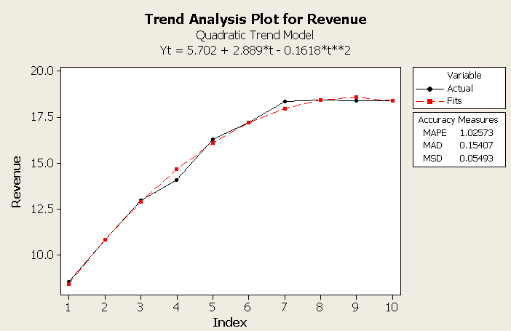

The quadratic trend equation is 

c. 

27. a.

The time series plot indicates curvature in the data.

b. The following output shows the results of using Minitab’s Time Series – Trend Analysis procedure to fit a quadratic trend equation to the time series.

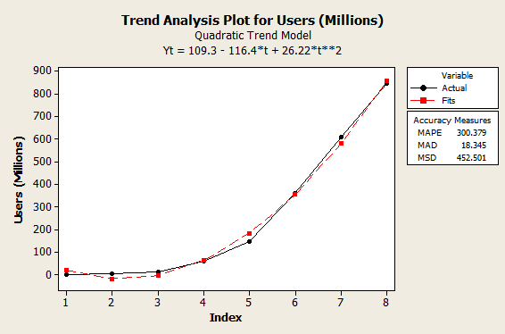

28. a.

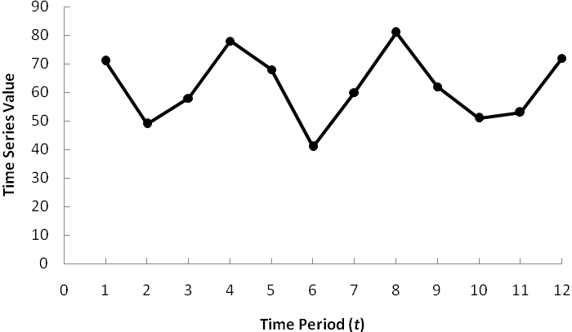

The time series plot shows a horizontal pattern. But, there is a seasonal pattern in the data. For instance, in each year the lowest value occurs in quarter 2 and the highest value occurs in quarter 4.

b. A portion of the Minitab regression output is shown below.

The regression equation is

Value = 77.0 - 10.0 Qtr1 - 30.0 Qtr2 - 20.0 Qtr3

c. The quarterly forecasts for next year are as follows:

Quarter 1 forecast = 77.0 - 10.0(1) - 30.0(0) - 20.0(0) = 67

Quarter 2 forecast = 77.0 - 10.0(0) - 30.0(1) - 20.0(0) = 47

Quarter 3 forecast = 77.0 - 10.0(0) - 30.0(0) - 20.0(1) = 57

Quarter 4 forecast = 77.0 - 10.0(0) - 30.0(0) - 20.0(0) = 77

29. a.

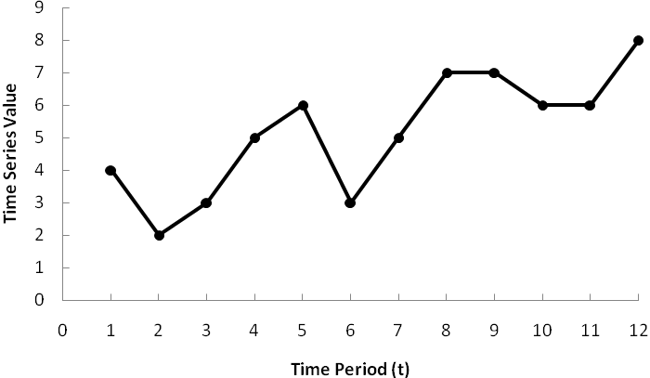

The time series plot shows a linear trend and a seasonal pattern in the data.

b. A portion of the Minitab regression output is shown below.

The regression equation is

Value = 3.42 + 0.219 Qtr1 - 2.19 Qtr2 - 1.59 Qtr3 + 0.406 t

c. The quarterly forecasts for next year (*t* = 13, 14, 15, and 16) are as follows:

Quarter 1 forecast = 3.42 + 0.219(1) - 2.19(0) - 1.59(0) + 0.406(13) = 8.92

Quarter 2 forecast = 3.42 + 0.219(0) - 2.19(1) - 1.59(0) + 0.406(14) = 6.91

Quarter 3 forecast = 3.42 + 0.219(0) - 2.19(0) - 1.59(1) + 0.406(15) = 7.92

Quarter 4 forecast = 3.42 + 0.219(0) - 2.19(0) - 1.59(0) + 0.406(16) = 9.92

30. a.

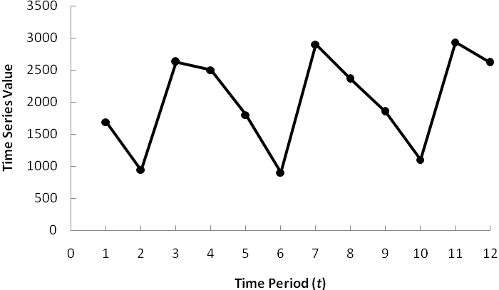

There appears to be a seasonal pattern in the data and perhaps a moderate upward linear trend.

b. A portion of the Minitab regression output follows.

The regression equation is

Value = 2492 - 712 Qtr1 - 1512 Qtr2 + 327 Qtr3

c. The quarterly forecasts for next year are as follows:

Quarter 1 forecast = 2492 – 712(1) – 1512(0) + 327(0) = 1780

Quarter 2 forecast = 2492 – 712(0) – 1512(1) + 327(0) = 980

Quarter 3 forecast = 2492 – 712(0) – 1512(0) + 327(1) = 2819

Quarter 4 forecast = 2492 – 712(0) – 1512(0) + 327(0) = 2492

d. A portion of the Minitab regression output follows.

The regression equation is

Value = 2307 - 642 Qtr1 - 1465 Qtr2 + 350 Qtr3 + 23.1 t

The quarterly forecasts for next year are as follows:

Quarter 1 forecast = 2307 – 642(1) – 1465(0) + 350(0) + 23.1(17) = 2058

Quarter 2 forecast = 2307 – 642(0) – 1465(1) + 350(0) + 23.1(18) = 1258

Quarter 3 forecast = 2307 – 642(0) – 1465(0) + 350(1) + 23.1(19) = 3096

Quarter 4 forecast = 2307 – 642(0) – 1465(0) + 350(0) + 23.1(20) = 2769

31. a.

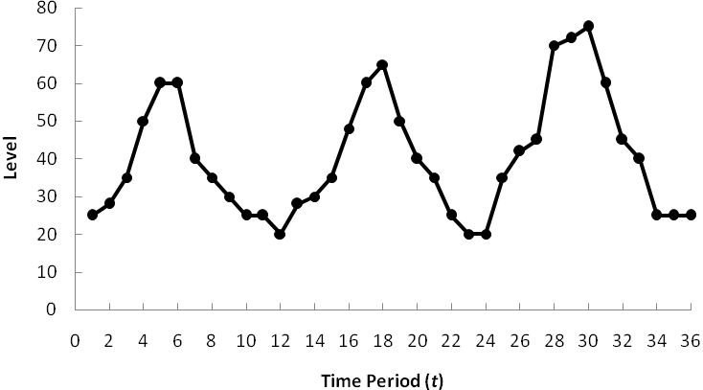

The time series plot indicates a seasonal pattern in the data and perhaps a slight upward linear trend.

b. A portion of the Minitab regression output follows.

The regression equation is

Level = 21.7 + 7.67 Hour1 + 11.7 Hour2 + 16.7 Hour3 + 34.3 Hour4 + 42.3 Hour5

+ 45.0 Hour6 + 28.3 Hour7 + 18.3 Hour8 + 13.3 Hour9 + 3.33 Hour10

+ 1.67 Hour11

Predictor Coef SE Coef T P

Constant 21.667 3.866 5.60 0.000

Hour1 7.667 5.467 1.40 0.174

Hour2 11.667 5.467 2.13 0.043

Hour3 16.667 5.467 3.05 0.006

Hour4 34.333 5.467 6.28 0.000

Hour5 42.333 5.467 7.74 0.000

Hour6 45.000 5.467 8.23 0.000

Hour7 28.333 5.467 5.18 0.000

Hour8 18.333 5.467 3.35 0.003

Hour9 13.333 5.467 2.44 0.023

Hour10 3.333 5.467 0.61 0.548

Hour11 1.667 5.467 0.30 0.763

c. The hourly forecasts for the next day can be obtained very easily using the estimated regression equation. For instance, setting Hour1 = 1 and the rest of the dummy variables equal to 0 provides the forecast for the first hour; setting Hour2 = 1 and the rest of the dummy variables equal to 0 provides the forecast for the second hour; and so on.

Forecast for hour 1 = 21.667 + 7.667(1) + 11.667(0) + 16.667(0) + 34.333 (0) + 42.333(0) + 45.000(0) + 28.333(0) + 18.333(0) + 13.333(0) + 3.333(0) + 1.667(0) = 29.33

Forecast for hour 2 = 21.667 + 7.667(0) + 11.667(1) + 16.667(0) + 34.333 (0) + 42.333(0) + 45.000(0) + 28.333(0) + 18.333(0) + 13.333(0) + 3.333(0) + 1.667(0) = 33.33

The forecasts for the remaining hours can be obtained similarly. But, since there is no trend the data the hourly forecasts can also be computed by simply taking the average of the three time series values for each hour.

|  |  |  |  |  |
| --- | --- | --- | --- | --- |
| **Hour** | **July 15** | **July 16** | **July 17** | **Average** |
| 1 | 25 | 28 | 35 | 29.33 |
| 2 | 28 | 30 | 42 | 33.33 |
| 3 | 35 | 35 | 45 | 38.33 |
| 4 | 50 | 48 | 70 | 56.00 |
| 5 | 60 | 60 | 72 | 64.00 |
| 6 | 60 | 65 | 75 | 66.67 |
| 7 | 40 | 50 | 60 | 50.00 |
| 8 | 35 | 40 | 45 | 40.00 |
| 9 | 30 | 35 | 40 | 35.00 |
| 10 | 25 | 25 | 25 | 25.00 |
| 11 | 25 | 20 | 25 | 23.33 |
| 12 | 20 | 20 | 25 | 21.67 |

In other words, the forecast for hour 1 is the average of the three observations for hour 1 on July 15, 16, and 17, or 29.33; the forecast for hour 2 is the average of the three observations for hour 1 on July 15, 16, and 17, or 33.33; and so on. Note that the forecast for the last hour is 21.67, the value of  in the estimated regression equation.

d. A portion of the Minitab regression output follows:

The regression equation is

Level = 11.2 + 12.5 Hour1 + 16.0 Hour2 + 20.6 Hour3 + 37.8 Hour4 + 45.4 Hour5 + 47.6 Hour6 + 30.5 Hour7 + 20.1 Hour8 + 14.6 Hour9 + 4.21 Hour10 + 2.10 Hour11 + 0.437 t

Predictor Coef SE Coef T P

Constant 11.167 3.002 3.72 0.001

Hour1 12.479 3.556 3.51 0.002

Hour2 16.042 3.541 4.53 0.000

Hour3 20.604 3.527 5.84 0.000

Hour4 37.833 3.514 10.77 0.000

Hour5 45.396 3.503 12.96 0.000

Hour6 47.625 3.493 13.63 0.000

Hour7 30.521 3.485 8.76 0.000

Hour8 20.083 3.478 5.77 0.000

Hour9 14.646 3.473 4.22 0.000

Hour10 4.208 3.469 1.21 0.237

Hour11 2.104 3.467 0.61 0.550

t 0.43750 0.07221 6.06 0.000

Hour 1 on July 18 corresponds to Hour1 = 1 and t = 37.

Forecast for hour 1 on July 18 = 11.167 + 12.479(1) + .4375(37) = 39.834

Hour 2 on July 18 corresponds to Hour2 = 1 and t = 38.

Forecast for hour 2 on July 18 = 11.167 + 16.042(1) + .4375(38) = 43.834

The forecasts for the other hours are computed in a similar manner. The following table shows the forecasts for the 12 hours on July 18.

|  |  |
| --- | --- |
| Hour 1 | 39.834 |
| Hour 2 | 43.834 |
| Hour 3 | 48.834 |
| Hour 4 | 66.500 |
| Hour 5 | 74.501 |
| Hour 6 | 77.167 |
| Hour 7 | 60.501 |
| Hour 8 | 50.500 |
| Hour 9 | 45.501 |
| Hour 10 | 35.500 |
| Hour 11 | 33.834 |
| Hour 12 | 32.167 |

32. a.

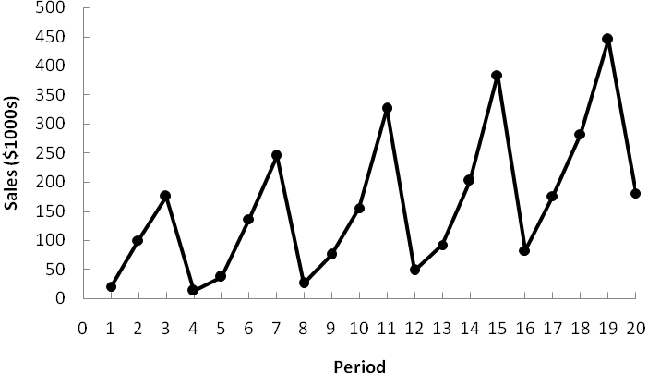

The time series plot shows both a linear trend and seasonal effects.

b. A portion of the Minitab regression output follows.

The regression equation is

Revenue = 70.0 + 10.0 Qtr1 + 105 Qtr2 + 245 Qtr3

Quarter 1 forecast = 70.0 + 10.0(1) + 105(0) + 245(0) = 80

Quarter 2 forecast = 70.0 + 10.0(0) + 105(1) + 245(0) = 175

Quarter 3 forecast = 70.0 + 10.0(0) + 105(0) + 245(1) = 315

Quarter 4 forecast = 70.0 + 10.0(0) + 105(0) + 245(0) = 70

c. A portion of the Minitab regression output follows.

The regression equation is

Revenue = - 70.1 + 45.0 Qtr1 + 128 Qtr2 + 257 Qtr3 + 11.7 Period

Quarter 1 forecast = -70.1 + 45.0(1) + 128(0) + 257(0) + 11.7(21) = 221

Quarter 2 forecast = -70.1 + 45.0(0) + 128(1) + 257(0) + 11.7(22) = 315

Quarter 3 forecast = -70.1 + 45.0(0) + 128(0) + 257(1) + 11.7(23) = 456

Quarter 4 forecast = -70.1 + 45.0(0) + 128(0) + 257(0) + 11.7(24) = 211

33. a.

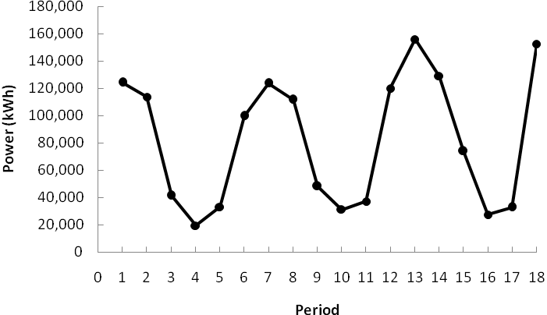

The time series plot indicates a seasonal effect. Power consumption is lowest in the time period 12-4 A.M., steadily increases to the highest value in the 12-4 P.M. time period, and then decreases again. There may also be some linear trend in the data.

b. A portion of the Minitab regression output follows.

The regression equation is

Power = 54445 - 28505 Time1 - 20137 Time2 + 69538 Time3 + 80221 Time4

+ 63605 Time5

c. The estimate of Timko’s power usage from noon to 8:00 P.M. on Thursday is

12-4 P.M. Forecast = 54445 – 28505(0) - 20137(0)+ 69538(0)+ 80221(1)+ 63605(0) = 134,666

4-8 P.M. Forecast = 54445 – 28505(0) - 20137(0)+ 69538(0)+ 80221(0)+ 63605(1) = 118,050

d. A portion of the Minitab regression output follows.

The regression equation is

Power = 36918 - 30452 Time1 - 24032 Time2 + 63696 Time3 + 84116 Time4

+ 65553 Time5 + 1947 Period

e. The estimate of Timko’s power usage from noon to 8:00 P.M. on Thursday Periods 19 and 20 is

12-4 P.M. Forecast = 36918 - 30452(0)- 24032(0)+ 63696(0)+ 84116(1) + 65553(0)+ 1947(19) = 158,027

4-8 P.M. Forecast = 36918 - 30452(0)- 24032(0)+ 63696(0)+ 84116(0) + 65553(1)+ 1947(20) = 141,411

34. a.

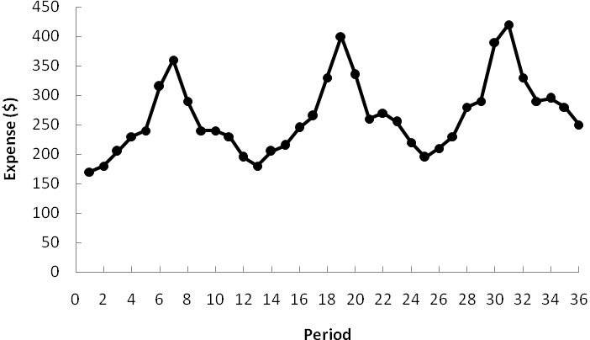

The time series plot shows seasonal and linear trend effects.

b. Note: Jan = 1 if January, 0 otherwise; Feb = 1 if February, 0 otherwise; and so on.

A portion of the Minitab regression output follows.

The regression equation is

Expense = 175 - 18.4 Jan - 3.72 Feb + 12.7 Mar + 45.7 Apr + 57.1 May + 135 Jun + 181 Jul + 105 Aug + 47.6 Sep + 50.6 Oct + 35.3 Nov + 1.96 Period

c. Note: The next time period in the time series is Period = 37 (January of Year 4).

January forecast = 175 - 18.4(1) - 3.72(0) + 12.7(0) + 45.7(0) + 57.1(0) + 135(0) + 181(0) + 105(0) + 47.6(0) + 50.6(0) + 35.3(0) + 1.96(37) = 229

February forecast = 175 - 18.4(0) - 3.72(1) + 12.7(0) + 45.7(0) + 57.1(0) + 135(0) + 181(0) + 105(0) + 47.6(0) + 50.6(0) + 35.3(0) + 1.96(38) = 246

March forecast = 175 - 18.4(0) - 3.72(0) + 12.7(1) + 45.7(0) + 57.1(0) + 135(0) + 181(0) + 105(0) + 47.6(0) + 50.6(0) + 35.3(0) + 1.96(39) = 264

April forecast = 175 - 18.4(0) - 3.72(0) + 12.7(0) + 45.7(1) + 57.1(0) + 135(0) + 181(0) + 105(0) + 47.6(0) + 50.6(0) + 35.3(0) + 1.96(40) = 299

May forecast = 175 - 18.4(0) - 3.72(0) + 12.7(0) + 45.7(0) + 57.1(1) + 135(0) + 181(0) + 105(0) + 47.6(0) + 50.6(0) + 35.3(0) + 1.96(41) = 312

June forecast = 175 - 18.4(0) - 3.72(0) + 12.7(0) + 45.7(0) + 57.1(0) + 135(1) + 181(0) + 105(0) + 47.6(0) + 50.6(0) + 35.3(0) + 1.96(42) = 392

July forecast = 175 - 18.4(0) - 3.72(0) + 12.7(0) + 45.7(0) + 57.1(0) + 135(0) + 181(1) + 105(0) + 47.6(0) + 50.6(0) + 35.3(0) + 1.96(43) = 440

August forecast = 175 - 18.4(0) - 3.72(0) + 12.7(0) + 45.7(0) + 57.1(0) + 135(0) + 181(0) + 105(1) + 47.6(0) + 50.6(0) + 35.3(0) + 1.96(44) = 366

September forecast = 175 - 18.4(0) - 3.72(0) + 12.7(0) + 45.7(0) + 57.1(0) + 135(0) + 181(0) + 105(0) + 47.6(1) + 50.6(0) + 35.3(0) + 1.96(45) = 311

October forecast = 175 - 18.4(0) - 3.72(0) + 12.7(0) + 45.7(0) + 57.1(0) + 135(0) + 181(0) + 105(0) + 47.6(0) + 50.6(1) + 35.3(0) + 1.96(46) = 316

November forecast = 175 - 18.4(0) - 3.72(0) + 12.7(0) + 45.7(0) + 57.1(0) + 135(0) + 181(0) + 105(0) + 47.6(0) + 50.6(0) + 35.3(1) + 1.96(47) = 302

December forecast = 175 - 18.4(0) - 3.72(0) + 12.7(0) + 45.7(0) + 57.1(0) + 135(0) + 181(0) + 105(0) + 47.6(0) + 50.6(0) + 35.3(0) + 1.96(48) = 269

35. a.

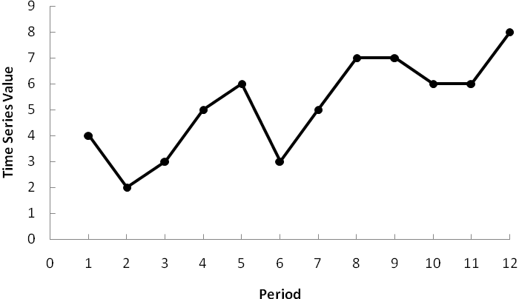

The time series plot indicates a linear trend and a seasonal pattern.

b.

|  |  |  |  |  |
| --- | --- | --- | --- | --- |
| **Year** | **Quarter** | **Time Series Value** | **Four-Quarter Moving Average** | **Centered Moving Average** |
| 1 | 1 | 4 |  |  |
|  |  |  |  |  |
|  | 2 | 2 |  |  |
|  |  |  | 3.50 |  |
|  | 3 | 3 |  | 3.750 |
|  |  |  | 4.00 |  |
|  | 4 | 5 |  | 4.125 |
|  |  |  | 4.25 |  |
| 2 | 1 | 6 |  | 4.500 |
|  |  |  | 4.75 |  |
|  | 2 | 3 |  | 5.000 |
|  |  |  | 5.25 |  |
|  | 3 | 5 |  | 5.375 |
|  |  |  | 5.50 |  |
|  | 4 | 7 |  | 5.875 |
|  |  |  | 6.25 |  |
| 3 | 1 | 7 |  | 6.375 |
|  |  |  | 6.50 |  |
|  | 2 | 6 |  | 6.625 |
|  |  |  | 6.75 |  |
|  | 3 | 6 |  |  |
|  |  |  |  |  |
|  | 4 | 8 |  |  |

c.

|  |  |  |  |  |
| --- | --- | --- | --- | --- |
| **Year** | **Quarter** | **Time Series Value** | **Centered Moving Average** | **Seasonal-Irregular Value** |
| 1 | 1 | 4 |  |  |
|  | 2 | 2 |  |  |
|  | 3 | 3 | 3.750 | 0.800 |
|  | 4 | 5 | 4.125 | 1.212 |
| 2 | 1 | 6 | 4.500 | 1.333 |
|  | 2 | 3 | 5.000 | 0.600 |
|  | 3 | 5 | 5.375 | 0.930 |
|  | 4 | 7 | 5.875 | 1.191 |
| 3 | 1 | 7 | 6.375 | 1.098 |
|  | 2 | 6 | 6.625 | 0.906 |
|  | 3 | 6 |  |  |
|  | 4 | 8 |  |  |

|  |  |  |  |  |
| --- | --- | --- | --- | --- |
| **Quarter** | **Seasonal-Irregular Values** | | **Seasonal Index** | **Adjusted Seasonal Index** |
| 1 | 1.333 | 1.098 | 1.216 | 1.205 |
| 2 | 0.600 | 0.906 | 0.753 | 0.746 |
| 3 | 0.800 | 0.930 | 0.865 | 0.857 |
| 4 | 1.212 | 1.191 | 1.202 | 1.191 |
|  |  | Total | 4.036 |  |

Note: Adjustment for seasonal index = 4.000 / 4.036 = 0.991

36. a.

|  |  |  |  |  |
| --- | --- | --- | --- | --- |
| **Year** | **Quarter** | **Time Series Value** | **Adjusted Seasonal Index** | **Deseasonalized Value** |
| 1 | 1 | 4 | 1.205 | 3.320 |
|  | 2 | 2 | 0.746 | 2.681 |
|  | 3 | 3 | 0.858 | 3.501 |
|  | 4 | 5 | 1.191 | 4.198 |
| 2 | 1 | 6 | 1.205 | 4.979 |
|  | 2 | 3 | 0.746 | 4.021 |
|  | 3 | 5 | 0.858 | 5.834 |
|  | 4 | 7 | 1.191 | 5.877 |
| 3 | 1 | 7 | 1.205 | 5.809 |
|  | 2 | 6 | 0.746 | 8.043 |
|  | 3 | 6 | 0.858 | 7.001 |
|  | 4 | 8 | 1.191 | 6.717 |

b. Let Period = 1 denote the time series value in Year 1 – Quarter 1; Period = 2 denote the time series value in Year 1 – Quarter 2; and so on. A portion of the Minitab regression output treating Period as the independent variable and the Deseasonlized Values as the values of the dependent variable follows.

The regression equation is

Deseasonalized Value = 2.42 + 0.422 Period

c. The quarterly deseasonalized trend forecasts for Year 4 (Periods 13, 14, 15, and 16) are as follows:

Forecast for quarter 1 = 2.42 + 0.422(13) = 7.906

Forecast for quarter 2 = 2.42 + 0.422(14) = 8.328

Forecast for quarter 3 = 2.42 + 0.422(15) = 8.750

Forecast for quarter 4 = 2.42 + 0.422(16) = 9.172

d. Adjusting the quarterly deseasonalized trend forecasts provides the following quarterly estimates:

Forecast for quarter 1 = 7.906(1.205) = 9.527

Forecast for quarter 2 = 8.328(.746) = 6.213

Forecast for quarter 3 = 8.750(.857) = 7.499

Forecast for quarter 4 = 9.172(1.191) = 10.924

37. a.

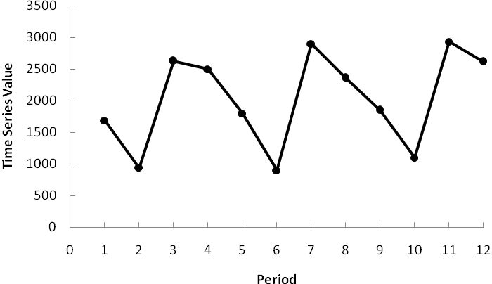

The time series plot indicates linear trend and seasonal pattern.

b.

|  |  |  |  |  |
| --- | --- | --- | --- | --- |
| **Year** | **Quarter** | **Time Series Value** | **Four-Quarter Moving Average** | **Centered Moving Average** |
| 1 | 1 | 1690 |  |  |
|  |  |  |  |  |
|  | 2 | 940 |  |  |
|  |  |  | 1938.75 |  |
|  | 3 | 2625 |  | 1952.500 |
|  |  |  | 1966.25 |  |
|  | 4 | 2500 |  | 1961.250 |
|  |  |  | 1956.25 |  |
| 2 | 1 | 1800 |  | 1990.625 |
|  |  |  | 2025.00 |  |
|  | 2 | 900 |  | 2007.500 |
|  |  |  | 1990.00 |  |
|  | 3 | 2900 |  | 1996.250 |
|  |  |  | 2002.50 |  |
|  | 4 | 2360 |  | 2027.500 |
|  |  |  | 2052.50 |  |
| 3 | 1 | 1850 |  | 2056.250 |
|  |  |  | 2060.00 |  |
|  | 2 | 1100 |  | 2091.875 |
|  |  |  | 2123.75 |  |
|  | 3 | 2930 |  |  |
|  |  |  |  |  |
|  | 4 | 2615 |  |  |

c.

|  |  |  |  |  |
| --- | --- | --- | --- | --- |
| **Year** | **Quarter** | **Time Series Value** | **Centered Moving Average** | **Seasonal-Irregular Value** |
| 1 | 1 | 1690 |  |  |
|  | 2 | 940 |  |  |
|  | 3 | 2625 | 1952.500 | 1.344 |
|  | 4 | 2500 | 1961.250 | 1.275 |
| 2 | 1 | 1800 | 1990.625 | 0.904 |
|  | 2 | 900 | 2007.500 | 0.448 |
|  | 3 | 2900 | 1996.250 | 1.453 |
|  | 4 | 2360 | 2027.500 | 1.164 |
| 3 | 1 | 1850 | 2056.250 | 0.900 |
|  | 2 | 1100 | 2091.875 | 0.526 |
|  | 3 | 2930 |  |  |
|  | 4 | 2615 |  |  |

|  |  |  |  |  |
| --- | --- | --- | --- | --- |
| **Quarter** | **Seasonal-Irregular Values** | | **Seasonal Index** | **Adjusted Seasonal Index** |
| 1 | 0.904 | 0.900 | 0.902 | 0.900 |
| 2 | 0.448 | 0.526 | 0.487 | 0.486 |
| 3 | 1.344 | 1.453 | 1.399 | 1.396 |
| 4 | 1.275 | 1.164 | 1.219 | 1.217 |
|  |  | Total | 4.007 |  |

Note: Adjustment for seasonal index = 4.000 / 4.007 = 0.998

d. The largest school effect is in the third quarter which corresponds to back-to-school demand during July, August, and September of each year.

e.

|  |  |  |  |  |
| --- | --- | --- | --- | --- |
| **Year** | **Quarter** | **Time Series Value** | **Adjusted Seasonal Index** | **Deseasonalized Value** |
| 1 | 1 | 1690 | 0.900 | 1877.778 |
|  | 2 | 940 | 0.486 | 1934.156 |
|  | 3 | 2625 | 1.396 | 1880.372 |
|  | 4 | 2500 | 1.217 | 2054.232 |
| 2 | 1 | 1800 | 0.900 | 2000.000 |
|  | 2 | 900 | 0.486 | 1851.852 |
|  | 3 | 2900 | 1.396 | 2077.364 |
|  | 4 | 2360 | 1.217 | 1939.195 |
| 3 | 1 | 1850 | 0.900 | 2055.556 |
|  | 2 | 1100 | 0.486 | 2263.374 |
|  | 3 | 2930 | 1.396 | 2098.854 |
|  | 4 | 2615 | 1.217 | 2148.726 |

f. Let Period = 1 denote the time series value in Year 1 – Quarter 1; Period = 2 denote the time series value in Year 1 – Quarter 2; and so on. A portion of the Minitab regression output treating Period as the independent variable and the Deseasonlized Values as the values of the dependent variable follows.

The regression equation is

Deseasonalized Value = 1852 + 25.2 Period

The quarterly deseasonalized trend forecasts for Year 4 (Periods 13, 14, 15, and 16) are as follows:

Forecast for quarter 1 = 1852 + 25.2(13) = 2179.6

Forecast for quarter 2 = 1852 + 25.2 (14) = 2204.8

Forecast for quarter 3 = 1852 + 25.2 (15) = 2230.0

Forecast for quarter 4 = 1852 + 25.2 (16) = 2255.2

g. Adjusting the quarterly deseasonalized trend forecasts provides the following quarterly estimates:

Forecast for quarter 1 = 2179.6(.900) = 1962

Forecast for quarter 2 = 2204.8(.486) = 1072

Forecast for quarter 3 = 2230.0(1.396) = 3113

Forecast for quarter 4 = 2255.2(1.217) = 2745

38. a.



The time series plot shows a linear trend and seasonal effects.

b.

|  |  |  |  |
| --- | --- | --- | --- |
| **Month** | **Expense** | **Centered Moving Average** | **Seasonal-Irregular Value** |
| 1 | 170 |  |  |
| 2 | 180 |  |  |
| 3 | 205 |  |  |
| 4 | 230 |  |  |
| 5 | 240 |  |  |
| 6 | 315 |  |  |
| 7 | 360 | 241.67 | 1.49 |
| 8 | 290 | 243.13 | 1.19 |
| 9 | 240 | 244.58 | 0.98 |
| 10 | 240 | 245.63 | 0.98 |
| 11 | 230 | 247.29 | 0.93 |
| 12 | 195 | 248.96 | 0.78 |
| 13 | 180 | 251.25 | 0.72 |
| 14 | 205 | 254.79 | 0.80 |
| 15 | 215 | 257.50 | 0.83 |
| 16 | 245 | 259.58 | 0.94 |
| 17 | 265 | 261.88 | 1.01 |
| 18 | 330 | 263.96 | 1.25 |
| 19 | 400 | 265.63 | 1.51 |
| 20 | 335 | 266.46 | 1.26 |
| 21 | 260 | 267.29 | 0.97 |
| 22 | 270 | 269.38 | 1.00 |
| 23 | 255 | 271.88 | 0.94 |
| 24 | 220 | 275.42 | 0.80 |
| 25 | 195 | 278.75 | 0.70 |
| 26 | 210 | 279.38 | 0.75 |
| 27 | 230 | 280.42 | 0.82 |
| 28 | 280 | 282.71 | 0.99 |
| 29 | 290 | 284.79 | 1.02 |
| 30 | 390 | 287.08 | 1.36 |
| 31 | 420 |  |  |
| 32 | 330 |  |  |
| 33 | 290 |  |  |
| 34 | 295 |  |  |
| 35 | 280 |  |  |
| 36 | 250 |  |  |

|  |  |  |  |
| --- | --- | --- | --- |
| **Month** | **Seasonal-Irregular**  **Values** | | **Seasonal Index** |
| 1 | 0.72 | 0.70 | 0.71 |
| 2 | 0.80 | 0.75 | 0.78 |
| 3 | 0.83 | 0.82 | 0.83 |
| 4 | 0.94 | 0.99 | 0.97 |
| 5 | 1.01 | 1.02 | 1.02 |
| 6 | 1.25 | 1.36 | 1.30 |
| 7 | 1.49 | 1.51 | 1.50 |
| 8 | 1.19 | 1.26 | 1.23 |
| 9 | 0.98 | 0.97 | 0.98 |
| 10 | 0.98 | 1.00 | 0.99 |
| 11 | 0.93 | 0.94 | 0.93 |
| 12 | 0.78 | 0.80 | 0.79 |
|  |  | Total | 12.03 |

Notes: 1. Adjustment for seasonal index = 12 / 12.03 = 0.998

2. Because the seasonal-irregular values and the seasonal index values were rounded to two decimal places to simplify the presentation, the adjustment is really not necessary in this problem since it implies more accuracy than is warranted.

c.

|  |  |  |  |
| --- | --- | --- | --- |
| **Month** | **Expense** | **Seasonal Index** | **Deaseasonalized**  **Expense** |
| 1 | 170 | 0.71 | 239.44 |
| 2 | 180 | 0.78 | 230.77 |
| 3 | 205 | 0.83 | 246.99 |
| 4 | 230 | 0.97 | 237.11 |
| 5 | 240 | 1.02 | 235.29 |
| 6 | 315 | 1.3 | 242.31 |
| 7 | 360 | 1.5 | 240.00 |
| 8 | 290 | 1.23 | 235.77 |
| 9 | 240 | 0.98 | 244.90 |
| 10 | 240 | 0.99 | 242.42 |
| 11 | 230 | 0.93 | 247.31 |
| 12 | 195 | 0.79 | 246.84 |
| 13 | 180 | 0.71 | 253.52 |
| 14 | 205 | 0.78 | 262.82 |
| 15 | 215 | 0.83 | 259.04 |
| 16 | 245 | 0.97 | 252.58 |
| 17 | 265 | 1.02 | 259.80 |
| 18 | 330 | 1.3 | 253.85 |
| 19 | 400 | 1.5 | 266.67 |
| 20 | 335 | 1.23 | 272.36 |
| 21 | 260 | 0.98 | 265.31 |
| 22 | 270 | 0.99 | 272.73 |
| 23 | 255 | 0.93 | 274.19 |
| 24 | 220 | 0.79 | 278.48 |
| 25 | 195 | 0.71 | 274.65 |
| 26 | 210 | 0.78 | 269.23 |
| 27 | 230 | 0.83 | 277.11 |
| 28 | 280 | 0.97 | 288.66 |
| 29 | 290 | 1.02 | 284.31 |
| 30 | 390 | 1.3 | 300.00 |
| 31 | 420 | 1.5 | 280.00 |
| 32 | 330 | 1.23 | 268.29 |
| 33 | 290 | 0.98 | 295.92 |
| 34 | 295 | 0.99 | 297.98 |
| 35 | 280 | 0.93 | 301.08 |
| 36 | 250 | 0.79 | 316.46 |

d. Let Period = 1 denote the time series value in January – Year 1; Period = 2 denote the time series value in February – Year 2; and so on. A portion of the Minitab regression output treating Period as the independent variable and the Deseasonlized Values as the values of the dependent variable follows.

The regression equation is

Deseasonalized Expense = 228 + 1.96 Period

Predictor Coef SE Coef T P

Constant 228.014 2.555 89.25 0.000

Period 1.9605 0.1204 16.28 0.000

S = 7.50498 R-Sq = 88.6% R-Sq(adj) = 88.3%

Analysis of Variance

Source DF SS MS F P

Regression 1 14932 14932 265.10 0.000

Residual Error 34 1915 56

Total 35 16847

e. The linear trend estimates for the deseasonalized time series and the adjustment based upon the seasonal effects are shown below.

|  |  |  |  |
| --- | --- | --- | --- |
| **Month** | **Deseasonalized Trend Forecast** | **Seasonal Index** | **Monthly Forecast** |
| January | 300.52 | 0.71 | 213.37 |
| February | 302.48 | 0.78 | 235.93 |
| March | 304.44 | 0.83 | 252.69 |
| April | 306.4 | 0.97 | 297.21 |
| May | 308.36 | 1.02 | 314.53 |
| June | 310.32 | 1.30 | 403.42 |
| July | 312.28 | 1.50 | 468.42 |
| August | 314.24 | 1.23 | 386.52 |
| September | 316.2 | 0.98 | 309.88 |
| October | 318.16 | 0.99 | 314.98 |
| November | 320.12 | 0.93 | 297.71 |
| December | 322.08 | 0.79 | 254.44 |

For instance, using the estimated regression equation the deseasonalized trend forecast for January in Year 4 (Period = 37) is 228 + 1.96(37) = 300.52. Since the January seasonal index is .71, the forecast for January is .71(300.52) = $213.37, or approximately $213. The other monthly forecasts were computed in a similar fashion.

39. a.



The time series plot indicates a seasonal pattern in the data and perhaps a slight upward linear trend.

b.

|  |  |  |  |  |
| --- | --- | --- | --- | --- |
| **Day** | **Hour** | **Reading** | **Centered Moving Average** | **Seasonal-Irregular Value** |
| July 15 | 1 | 25 |  |  |
|  | 2 | 28 |  |  |
|  | 3 | 35 |  |  |
|  | 4 | 50 |  |  |
|  | 5 | 60 |  |  |
|  | 6 | 60 |  |  |
|  | 7 | 40 | 36.208 | 1.105 |
|  | 8 | 35 | 36.417 | 0.961 |
|  | 9 | 30 | 36.500 | 0.822 |
|  | 10 | 25 | 36.417 | 0.686 |
|  | 11 | 25 | 36.333 | 0.688 |
|  | 12 | 20 | 36.542 | 0.547 |
| July 16 | 1 | 28 | 37.167 | 0.753 |
|  | 2 | 30 | 37.792 | 0.794 |
|  | 3 | 35 | 38.208 | 0.916 |
|  | 4 | 48 | 38.417 | 1.249 |
|  | 5 | 60 | 38.208 | 1.570 |
|  | 6 | 65 | 38.000 | 1.711 |
|  | 7 | 50 | 38.292 | 1.306 |
|  | 8 | 40 | 39.083 | 1.023 |
|  | 9 | 35 | 40.000 | 0.875 |
|  | 10 | 25 | 41.333 | 0.605 |
|  | 11 | 20 | 42.750 | 0.468 |
|  | 12 | 20 | 43.667 | 0.458 |
| July 17 | 1 | 35 | 44.500 | 0.787 |
|  | 2 | 42 | 45.125 | 0.931 |
|  | 3 | 45 | 45.542 | 0.988 |
|  | 4 | 70 | 45.750 | 1.530 |
|  | 5 | 72 | 45.958 | 1.567 |
|  | 6 | 75 | 46.375 | 1.617 |
|  | 7 | 60 |  |  |
|  | 8 | 45 |  |  |
|  | 9 | 40 |  |  |
|  | 10 | 25 |  |  |
|  | 11 | 25 |  |  |
|  | 12 | 25 |  |  |

|  |  |  |  |  |
| --- | --- | --- | --- | --- |
| **Hour** | **Seasonal-Irregular Values** | | **Seasonal Index** | **Adjusted Seasonal Index** |
| 1 | 0.787 | 0.753 | 0.770 | 0.771 |
| 2 | 0.931 | 0.794 | 0.862 | 0.864 |
| 3 | 0.988 | 0.916 | 0.952 | 0.954 |
| 4 | 1.530 | 1.249 | 1.390 | 1.392 |
| 5 | 1.567 | 1.570 | 1.568 | 1.571 |
| 6 | 1.617 | 1.711 | 1.664 | 1.667 |
| 7 | 1.105 | 1.306 | 1.205 | 1.207 |
| 8 | 0.961 | 1.023 | 0.992 | 0.994 |
| 9 | 0.822 | 0.875 | 0.848 | 0.850 |
| 10 | 0.686 | 0.605 | 0.646 | 0.647 |
| 11 | 0.688 | 0.468 | 0.578 | 0.579 |
| 12 | 0.547 | 0.458 | 0.503 | 0.504 |

c. The adjusted seasonal indexes can now be used to deseasonalize the data as shown below.

|  |  |  |  |  |  |  |
| --- | --- | --- | --- | --- | --- | --- |
| **Day** | **Hour** | **Reading** | **Centered Moving Average** | **Seasonal-Irregular Value** | **Seasonal Index** | **Deseasonalized Reading** |
| July 15 | 1 | 25 |  |  | 0.771 | 32.412 |
|  | 2 | 28 |  |  | 0.864 | 32.414 |
|  | 3 | 35 |  |  | 0.954 | 36.697 |
|  | 4 | 50 |  |  | 1.392 | 35.914 |
|  | 5 | 60 |  |  | 1.571 | 38.186 |
|  | 6 | 60 |  |  | 1.667 | 35.996 |
|  | 7 | 40 | 36.208 | 1.105 | 1.207 | 33.129 |
|  | 8 | 35 | 36.417 | 0.961 | 0.994 | 35.210 |
|  | 9 | 30 | 36.500 | 0.822 | 0.850 | 35.295 |
|  | 10 | 25 | 36.417 | 0.686 | 0.647 | 38.651 |
|  | 11 | 25 | 36.333 | 0.688 | 0.579 | 43.179 |
|  | 12 | 20 | 36.542 | 0.547 | 0.504 | 39.717 |
| July 16 | 1 | 28 | 37.167 | 0.753 | 0.771 | 36.302 |
|  | 2 | 30 | 37.792 | 0.794 | 0.864 | 34.729 |
|  | 3 | 35 | 38.208 | 0.916 | 0.954 | 36.697 |
|  | 4 | 48 | 38.417 | 1.249 | 1.392 | 34.477 |
|  | 5 | 60 | 38.208 | 1.570 | 1.571 | 38.186 |
|  | 6 | 65 | 38.000 | 1.711 | 1.667 | 38.996 |
|  | 7 | 50 | 38.292 | 1.306 | 1.207 | 41.412 |
|  | 8 | 40 | 39.083 | 1.023 | 0.994 | 40.240 |
|  | 9 | 35 | 40.000 | 0.875 | 0.850 | 41.178 |
|  | 10 | 25 | 41.333 | 0.605 | 0.647 | 38.651 |
|  | 11 | 20 | 42.750 | 0.468 | 0.579 | 34.543 |
|  | 12 | 20 | 43.667 | 0.458 | 0.504 | 39.717 |

|  |  |  |  |  |  |  |
| --- | --- | --- | --- | --- | --- | --- |
| July 17 | 1 | 35 | 44.500 | 0.787 | 0.771 | 45.377 |
|  | 2 | 42 | 45.125 | 0.931 | 0.864 | 48.621 |
|  | 3 | 45 | 45.542 | 0.988 | 0.954 | 47.182 |
|  | 4 | 70 | 45.750 | 1.530 | 1.392 | 50.279 |
|  | 5 | 72 | 45.958 | 1.567 | 1.571 | 45.823 |
|  | 6 | 75 | 46.375 | 1.617 | 1.667 | 44.995 |
|  | 7 | 60 |  |  | 1.207 | 49.694 |
|  | 8 | 45 |  |  | 0.994 | 45.270 |
|  | 9 | 40 |  |  | 0.850 | 47.061 |
|  | 10 | 25 |  |  | 0.647 | 38.651 |
|  | 11 | 25 |  |  | 0.579 | 43.179 |
|  | 12 | 25 |  |  | 0.504 | 49.646 |

d. The following Minitab regression output shows the trend line fitted to the deseasonalized data.

The regression equation is

Deseasonalized Reading = 33.0 + 0.392 t

Predictor Coef SE Coef T P

Constant 32.956 1.145 28.77 0.000

t 0.39232 0.05398 7.27 0.000

S = 3.36466 R-Sq = 60.8% R-Sq(adj) = 59.7%

Analysis of Variance

Source DF SS MS F P

Regression 1 597.97 597.97 52.82 0.000

Residual Error 34 384.91 11.32

Total 35 982.88

e. Using the estimated regression equation Deseasonalized Reading = 33.0 + 0.392*t*, the linear trend estimates for the deseasonalized time series and the adjustment based upon the hourly effects are shown below.

|  |  |  |  |  |
| --- | --- | --- | --- | --- |
| ***t*** | **Hour** | **Deseasonalized Trend Forecast** | **Seasonal Index** | **Hourly Forecast** |
| 37 | 1 | 47.504 | 0.770 | 37 |
| 38 | 2 | 47.896 | 0.862 | 41 |
| 39 | 3 | 48.288 | 0.952 | 46 |
| 40 | 4 | 48.68 | 1.390 | 68 |
| 41 | 5 | 49.072 | 1.568 | 77 |
| 42 | 6 | 49.464 | 1.664 | 82 |
| 43 | 7 | 49.856 | 1.205 | 60 |
| 44 | 8 | 50.248 | 0.992 | 50 |
| 45 | 9 | 50.64 | 0.848 | 43 |
| 46 | 10 | 51.032 | 0.646 | 33 |
| 47 | 11 | 51.424 | 0.578 | 30 |
| 48 | 12 | 51.816 | 0.503 | 26 |

40. a.



The time series plot indicates a seasonal effect. Power consumption is lowest in the time period 12-4 A.M., steadily increases to the highest value in the 12-4 P.M. time period, and then decreases again. There may also be some linear trend in the data.

b.

|  |  |  |  |  |
| --- | --- | --- | --- | --- |
| **Day** | **Time Period** | **Power** | **Centered Moving Average** | **Seasonal-Irregular Values** |
| Monday | 12-4 p.m. | 124299 |  |  |
| Monday | 4-8 p.m. | 113545 |  |  |
| Monday | 8-12 midnight | 41300 |  |  |
| Tuesday | 12-4 a.m. | 19281 | 71803.3 | 0.2685 |
| Tuesday | 4-8 a.m. | 33195 | 71598.2 | 0.4636 |
| Tuesday | 8-12 noon | 99516 | 72013.5 | 1.3819 |
| Tuesday | 12-4 p.m. | 123666 | 73575.2 | 1.6808 |
| Tuesday | 4-8 p.m. | 111717 | 74887.4 | 1.4918 |
| Tuesday | 8-12 midnight | 48112 | 76910.0 | 0.6256 |
| Wednesday | 12-4 a.m. | 31209 | 81311.6 | 0.3838 |
| Wednesday | 4-8 a.m. | 37014 | 85439.8 | 0.4332 |
| Wednesday | 8-12 noon | 119968 | 89021.8 | 1.3476 |
| Wednesday | 12-4 p.m. | 156033 | 90849.4 | 1.7175 |
| Wednesday | 4-8 p.m. | 128889 | 90167.9 | 1.4294 |
| Wednesday | 8-12 midnight | 73923 | 92517.8 | 0.7990 |
| Thursday | 12-4 a.m. | 27330 |  |  |
| Thursday | 4-8 a.m. | 32715 |  |  |
| Thursday | 8-12 noon | 152465 |  |  |

|  |  |  |  |  |
| --- | --- | --- | --- | --- |
| **Time Period** | **Seasonal-Irregular Values** | | **Seasonal Index** | **Adjusted Seasonal Index** |
| 12-4 a.m. | 0.3838 | 0.2685 | 0.3262 | 0.3256 |
| 4-8 a.m. | 0.4332 | 0.4636 | 0.4484 | 0.4476 |
| 8-12 noon | 1.3476 | 1.3819 | 1.3648 | 1.3622 |
| 12-4 p.m. | 1.6808 | 1.7175 | 1.6992 | 1.6959 |
| 4-8 p.m. | 1.4918 | 1.4294 | 1.4606 | 1.4578 |
| 8-12 midnight | 0.6256 | 0.7990 | 0.7123 | 0.7109 |
|  |  | Total | 6.0114 |  |

c.

|  |  |  |  |  |
| --- | --- | --- | --- | --- |
| **Day** | **Time Period** | **Power** | **Adjusted Seasonal Index** | **Deseasonalized Power** |
| Monday | 12-4 p.m. | 124299 | 1.6959 | 73292.80 |
| Monday | 4-8 p.m. | 113545 | 1.4578 | 77885.67 |
| Monday | 8-12 midnight | 41300 | 0.7109 | 58092.48 |
| Tuesday | 12-4 a.m. | 19281 | 0.3256 | 59225.36 |
| Tuesday | 4-8 a.m. | 33195 | 0.4476 | 74166.93 |
| Tuesday | 8-12 noon | 99516 | 1.3622 | 73056.72 |
| Tuesday | 12-4 p.m. | 123666 | 1.6959 | 72919.55 |
| Tuesday | 4-8 p.m. | 111717 | 1.4578 | 76631.76 |
| Tuesday | 8-12 midnight | 48112 | 0.7109 | 67674.22 |
| Wednesday | 12-4 a.m. | 31209 | 0.3256 | 95864.54 |
| Wednesday | 4-8 a.m. | 37014 | 0.4476 | 82699.65 |
| Wednesday | 8-12 noon | 119968 | 1.3622 | 88070.95 |
| Wednesday | 12-4 p.m. | 156033 | 1.6959 | 92004.73 |
| Wednesday | 4-8 p.m. | 128889 | 1.4578 | 88410.82 |
| Wednesday | 8-12 midnight | 73923 | 0.7109 | 103979.91 |
| Thursday | 12-4 a.m. | 27330 | 0.3256 | 83949.43 |
| Thursday | 4-8 a.m. | 32715 | 0.4476 | 73094.48 |
| Thursday | 8-12 noon | 152465 | 1.3622 | 111927.66 |

The following Minitab output shows the results of fitting a linear trend equation to the deseasonalized time series.

The regression equation is

Deseasonalized Power = 63108 + 1854 t

Predictor Coef SE Coef T P

Constant 63108 5185 12.17 0.000

t 1853.8 479.0 3.87 0.001

Using the deseasonalized linear trend equation and the seasonal indexes computed in part (b) we can forecast power consumption for the 12-4 P.M. time period and the 4-8 P.M. time period.

12-4 P.M. (corresponds to *t* = 19)

Deseasonalized Power = 63108 + 1854(19) = 98,334

Seasonal Index for this period = 1.6959

Forecast for 12-4 P.M. = 1.6959(98,334) = 166,764.63 or approximately 166,765 kWh

4-8 P.M. (corresponds to *t* = 20)

Deseasonalized Power = 63108 + 1854(20) = 100,188

Seasonal Index for this period = 1.4578

Forecast for 4-8 P.M. = 1.4578(100,188) = 146,054.07 or approximately 146,054 kWh

Thus, the forecast of power consumption from noon to 8 P.M. is 166,765 + 146,054 = 312,819 kWh

41. a.

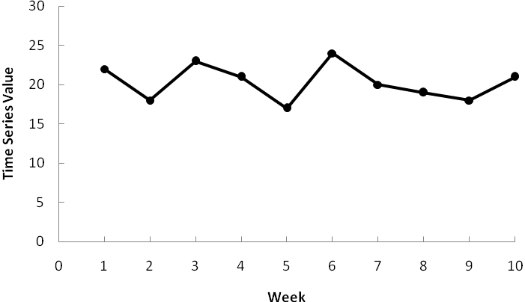

The time series plot indicates a horizontal pattern.

b. Three-week moving average.

|  |  |  |  |  |
| --- | --- | --- | --- | --- |
| **Week** | **Time Series Value** | **Forecast** | **Forecast Error** | **Squared Forecast Error** |
| 1 | 22 |  |  |  |
| 2 | 18 |  |  |  |
| 3 | 23 |  |  |  |
| 4 | 21 | 21.00 | 0.00 | 0.00 |
| 5 | 17 | 20.67 | -3.67 | 13.44 |
| 6 | 24 | 20.33 | 3.67 | 13.44 |
| 7 | 20 | 20.67 | -0.67 | 0.44 |
| 8 | 19 | 20.33 | -1.33 | 1.78 |
| 9 | 18 | 21.00 | -3.00 | 9.00 |
| 10 | 21 | 19.00 | 2.00 | 4.00 |
|  |  |  | Total | 42.11 |

MSE = 42.11 / 7 = 6.02

*F*11 = (19 + 18 + 21) / 3 = 19.33

c. Exponential smoothing using *α* = .2

|  |  |  |  |  |
| --- | --- | --- | --- | --- |
| **Week** | **Time Series Value** | **Forecast** | **Forecast Error** | **Squared Value of Forecast Error** |
| 1 | 22 |  |  |  |
| 2 | 18 | 22.00 | -4.00 | 16.00 |
| 3 | 23 | 21.20 | 1.80 | 3.24 |
| 4 | 21 | 21.56 | -0.56 | 0.31 |
| 5 | 17 | 21.45 | -4.45 | 19.78 |
| 6 | 24 | 20.56 | 3.44 | 11.84 |
| 7 | 20 | 21.25 | -1.25 | 1.55 |
| 8 | 19 | 21.00 | -2.00 | 3.99 |
| 9 | 18 | 20.60 | -2.60 | 6.75 |
| 10 | 21 | 20.08 | 0.92 | 0.85 |
|  |  |  | Total | 64.33 |

MSE = 64.33/ / 9 = 7.15

*F*11 = 0.2(21) + 0.8(20.08) = 20.26

d. The 3-month moving average is preferable. It has a smaller MSE.

42. a.

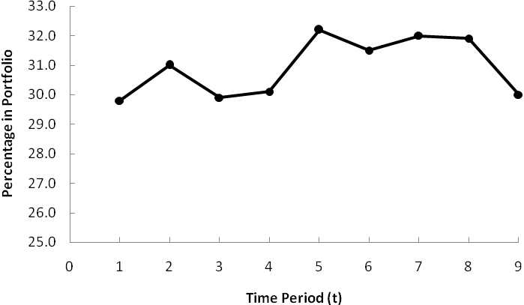

The time series plot indicates a horizontal pattern.

b.

|  |  |  |  |  |
| --- | --- | --- | --- | --- |
| Period | Time Series  Value | *α* = .2  Forecasts | *α* = .3  Forecasts | *α* = .4  Forecasts |
| 1 | 29.8 |  |  |  |
| 2 | 31.0 | 29.80 | 29.80 | 29.80 |
| 3 | 29.9 | 30.04 | 30.16 | 30.28 |
| 4 | 30.1 | 30.01 | 30.08 | 30.13 |
| 5 | 32.2 | 30.03 | 30.09 | 30.12 |
| 6 | 31.5 | 30.46 | 30.72 | 30.95 |
| 7 | 32.0 | 30.67 | 30.95 | 31.17 |
| 8 | 31.9 | 30.94 | 31.27 | 31.50 |
| 9 | 30.0 | 31.13 | 31.46 | 31.66 |

MSE(*α* = .2) = 11.22/8 = 1.40

MSE(*α* = .3) = 10.19/8 = 1.27

MSE(*α* = .4) = 9.83/8 = 1.23

A smoothing constant of *α* = .4 provides the best forecast because it has a smaller MSE

c. Using *α* = .4, *F*10 = .4(30) + .6(31.66) = 31.00

43. a.

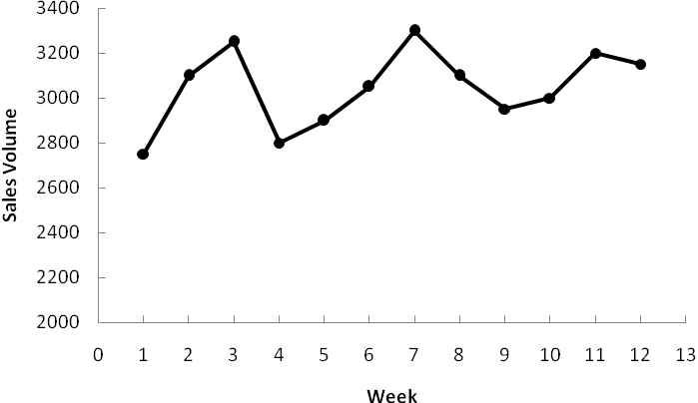

The time series plot indicates a horizontal pattern.

b.

|  |  |  |  |  |
| --- | --- | --- | --- | --- |
| **Week** | **Sales Volume** | **Forecast** | **Forecast Error** | **Squared Value of Forecast Error** |
| 1 | 2750 |  |  |  |
| 2 | 3100 | 2750.00 | 350.000 | 122,500.00 |
| 3 | 3250 | 2890.00 | 360.000 | 129,600.00 |
| 4 | 2800 | 3034.00 | -234.000 | 54,756.00 |
| 5 | 2900 | 2940.40 | -40.400 | 1,632.16 |
| 6 | 3050 | 2924.24 | 125.760 | 15,815.58 |
| 7 | 3300 | 2974.54 | 325.456 | 105,921.61 |
| 8 | 3100 | 3104.73 | -4.726 | 22.34 |
| 9 | 2950 | 3102.84 | -152.836 | 23,358.79 |
| 10 | 3000 | 3041.70 | -41.702 | 1,739.02 |
| 11 | 3200 | 3025.02 | 174.979 | 30,617.68 |
| 12 | 3150 | 3095.01 | 54.987 | 3,023.62 |
|  |  |  | Total | 488,986.80 |

Note: MSE = 488,986.80/11 = 44,453

Forecast for week 13 = .4(3150) + .6(3095.01) = 3117.01 or 3117 half-gallons of milk.

44. a.

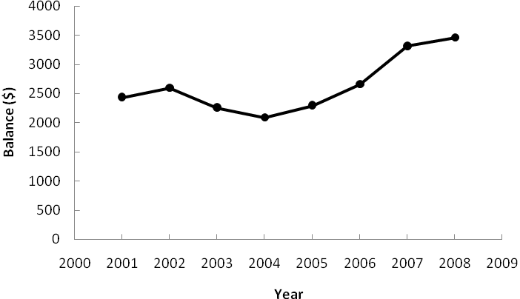

There appears to be an increasing trend in the data.

b. A portion of the Minitab regression output follows. Note: *t* = 1 corresponds to 2001, *t* = 2 corresponds to 2002, and so on.

The regression equation is

Balance($) = 1984 + 146 t

The forecast for 2009 (*t* = 9) is Balance ($) = 1984 + 146(9) = $3298

c. A portion of the Minitab regression output follows. Note: *t* = 1 corresponds to 2001, *t* = 2 corresponds to 2002, and so on.

The regression equation is

Balance($) = 2924 - 419 t + 62.7 tsq

The forecast for 2009 (*t* = 9) is Balance ($) = 2924 – 419(9) + 62.7(9)2 = $4232

d. Linear trend equation: MSE = 143,487 Quadratic trend equation: MSE = 40,183

The quadratic trend equation provides the best forecast accuracy for the historical data.

e. The following graph displays shows the linear trend equation and quadratic trend equation on the time series plot. Note that the difference between the quadratic trend forecast for 2009 and the linear trend forecast for 2009 is $4232 - $3298 = $934.

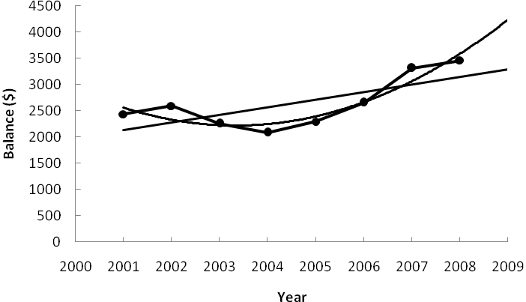

The key question is whether we believe that the average balance required will continue to rise as rapidly as the quadratic trend equation suggests. Looking more closely at the time series data, note that if we looked only at the time series values for 2001 – 2006, we would observe an underlying horizontal pattern. In fact, it looks like the average balance bottomed out in 2004 and has started to increase in a linear fashion over the time period 2004 – 2008. As a result, it may be worth considering fitting just a linear trend equation to the time series data for 2004 – 2008. In any event, we would not recommend use of a quadratic trend equation even though it provided the best fit for the historical data.

45. a.

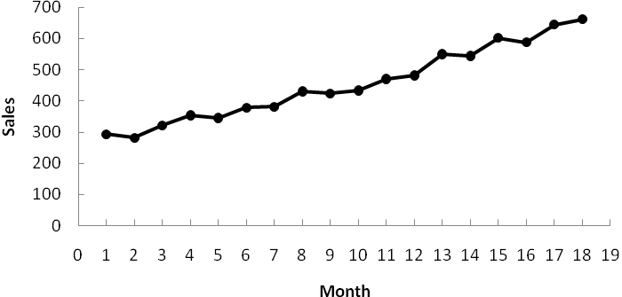

The time series plot shows a linear trend.

b.

|  |  |
| --- | --- |
| Smoothing Constant | MSE |
| ** = .3 | 4,492.37 |
| ** = .4 | 2,964.67 |
| ** = .5 | 2,160.31 |

The ** = .5 smoothing constant is better because it has the smallest MSE.

c. *Tt* = 244.778 + 22.088*t*

MSE = 357.81

d. Trend projection provides much better forecasts because it has the smallest MSE. The reason MSE is smaller for trend projection is that sales are increasing over time; as a result, exponential smoothing continuously underestimates the value of sales. If you look at the forecast errors for exponential smoothing you will see that the forecast errors are positive for periods 2 through 18.

46. a. The following table shows the calculations using a smoothing constant of .4.

|  |  |  |
| --- | --- | --- |
| **Month** | **Sales ($1000s)** | **Forecast** |
| January | 185.72 |  |
| February | 167.84 | 185.72 |
| March | 205.11 | 178.57 |
| April | 210.36 | 189.18 |
| May | 255.57 | 197.65 |
| June | 261.19 | 220.82 |

The forecast for July is .4(261.19) + .6(220.82) = 236.97

Forecast for August, using forecast for July as the actual sales in July, is 236.97.

Exponential smoothing provides the same forecast for every period in the future. This is why it is not usually recommended for long-term forecasting.

b. Using Minitab’s regression procedure we obtained the linear trend equation

*Tt* = 149.72 + 18.451*t*

Forecast for July (*t* = 7) is 149.72 + 18.451(7) = 278.88

Forecast for August (*t* = 8) is 149.72 + 18.451(8) = is 297.33

c. The proposed settlement is not fair since it does not account for the upward trend in sales. Based upon trend projection, the settlement should be based on forecasted lost sales of $278,880 in July and $297,330 in August.

47. a.

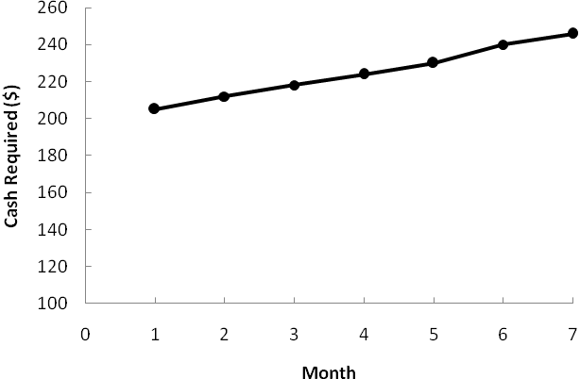

The time series plot indicates a linear trend.

b. Holt’s linear exponential smoothing using *α* = .6 and *β* = .4

|  |  |  |  |  |  |  |
| --- | --- | --- | --- | --- | --- | --- |
| **Month** | **Cash Required ($1000s)** | **Estimated Level** | **Estimated Trend** | **Forecast** | **Forecast Error** | **Squared Value of Forecast Error** |
| 1 | 205 | 205.00 | 7.00 |  |  |  |
| 2 | 212 | 212.00 | 7.00 | 212.00 | 0.00 | 0.00 |
| 3 | 218 | 218.40 | 6.76 | 219.00 | -1.00 | 1.00 |
| 4 | 224 | 224.46 | 6.48 | 225.16 | -1.16 | 1.35 |
| 5 | 230 | 230.38 | 6.25 | 230.95 | -0.95 | 0.89 |
| 6 | 240 | 238.65 | 7.06 | 236.63 | 3.37 | 11.34 |
| 7 | 246 | 245.89 | 7.13 | 245.72 | 0.28 | 0.08 |
|  |  |  |  |  | Total | 14.66 |

Forecast for month 8 = 245.89 + 7.13(1) = 253

Forecast for month 9 = 245.89 + 7.13(2) = 260

c. A portion of the Minitab regression output follows.

The regression equation is

Cash Required ($1000s) = 198 + 6.82 Month

Predictor Coef SE Coef T P

Constant 197.714 1.008 196.22 0.000

Month 6.8214 0.2253 30.28 0.000

S = 1.19224 R-Sq = 99.5% R-Sq(adj) = 99.3%

Analysis of Variance

Source DF SS MS F P

Regression 1 1302.9 1302.9 916.61 0.000

Residual Error 5 7.1 1.4

Total 6 1310.0

Forecast for month 8 = 197.714 + 6.8214(8) = 252

Forecast for month 9 = 197.714 + 6.8214(9) = 259

d. Holt’s linear exponential smoothing using *α* = .6 and *β* = .4: MSE = 14.66/6 = 2.44

Linear trend regression: MSE = 1.4 from the regression output; recall, however, that this value of MSE is not the average sum of squared errors that is computed using Holt’s method.

48. a.

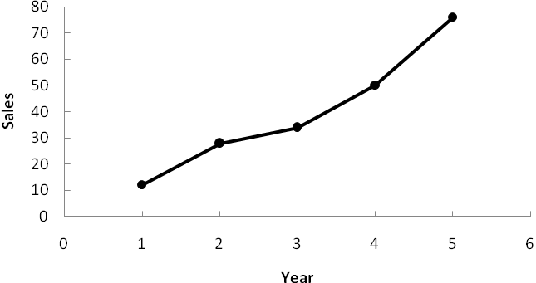

The time series plot shows a linear trend.

b. 









The slope of 15 indicates that the average increase in sales is 15 pianos per year.

c. Forecast for year 6 is 

Forecast for year 7 is 

49. a. A portion of the Minitab regression output follows.

The regression equation is

Sales = 7.15 - 5.59 Qtr1 - 10.9 Qtr2 - 11.5 Qtr3 + 0.937 t

Predictor Coef SE Coef T P

Constant 7.150 2.283 3.13 0.007

Qtr1 -5.587 2.253 -2.48 0.025

Qtr2 -10.925 2.232 -4.90 0.000

Qtr3 -11.463 2.219 -5.17 0.000

t 0.9375 0.1384 6.77 0.000

b. Quarterly forecasts for next year correspond to *t* = 21, 22, 23, and 24.

Forecast for Quarter 1 (*t* = 21) = 7.150 -5.587(1) -10.925(0) -11.463(0) + .9375(21) = 21.25

Forecast for Quarter 2 (*t* = 22) = 7.150 -5.587(0) -10.925(1) -11.463(0) + .9375(22) = 16.85

Forecast for Quarter 3 (*t* = 23) = 7.150 -5.587(0) -10.925(0) -11.463(1) + .9375(23) = 17.25

Forecast for Quarter 4 (*t* = 24) = 7.150 -5.587(0) -10.925(0) -11.463(0) + .9375(24) = 29.65

50. a.

|  |  |  |  |
| --- | --- | --- | --- |
| *t* | Sales | Centered  Moving Average | Seasonal-Irregular Value |
| 1 | 4 |  |  |
| 2 | 2 |  |  |
| 3 | 1 | 3.250 | 0.308 |
| 4 | 5 | 3.750 | 1.333 |
| 5 | 6 | 4.375 | 1.371 |
| 6 | 4 | 5.875 | 0.681 |
| 7 | 4 | 7.500 | 0.533 |
| 8 | 14 | 7.875 | 1.778 |
| 9 | 10 | 7.875 | 1.270 |
| 10 | 3 | 8.250 | 0.364 |
| 11 | 5 | 8.750 | 0.571 |
| 12 | 16 | 9.750 | 1.641 |
| 13 | 12 | 10.750 | 1.116 |
| 14 | 9 | 11.750 | 0.766 |
| 15 | 7 | 13.250 | 0.528 |
| 16 | 22 | 14.125 | 1.558 |
| 17 | 18 | 15.000 | 1.200 |
| 18 | 10 | 17.375 | 0.576 |
| 19 | 13 |  |  |
| 20 | 35 |  |  |

|  |  |  |  |  |
| --- | --- | --- | --- | --- |
| Quarter | Seasonal-Irregular  Values | | Seasonal  Index | |
| 1 | 1.371, 1.270, 1.116, 1.200 | | 1.2394 | |
| 2 | 0.681, 0.364, 0.776, 0.576 | | 0.5965 | |
| 3 | 0.308, 0.533, 0.571, 0.528 | | 0.4852 | |
| 4 | 1.333, 1.778, 1.641, 1.558 | | 1.5774 | |
|  | Total | | 3.8985 | |
|  | |  | |
| Quarter | | Adjusted Seasonal Index | |
| 1 | | 1.2717 | |
| 2 | | 0.6120 | |
| 3 | | 0.4978 | |
| 4 | | 1.6185 | |

Note: Adjustment for seasonal index = 4 / 3.8985 = 1.0260

b. The largest effect is in quarter 4; this seems reasonable since retail sales are generally higher during October, November, and December.

51. a. Note: the adjusted seasonal indexes were computed in Exercise 50

|  |  |  |  |  |
| --- | --- | --- | --- | --- |
| **Year** | **Quarter** | **Sales** | **Adjusted Seasonal Index** | **Deseasonalized Sales** |
| 1 | 1 | 4 | 1.2717 | 3.1454 |
|  | 2 | 2 | 0.6120 | 3.2680 |
|  | 3 | 1 | 0.4978 | 2.0088 |
|  | 4 | 5 | 1.6185 | 3.0893 |
| 2 | 1 | 6 | 1.2717 | 4.7181 |
|  | 2 | 4 | 0.6120 | 6.5359 |
|  | 3 | 4 | 0.4978 | 8.0354 |
|  | 4 | 14 | 1.6185 | 8.6500 |
| 3 | 1 | 10 | 1.2717 | 7.8635 |
|  | 2 | 3 | 0.6120 | 4.9020 |
|  | 3 | 5 | 0.4978 | 10.0442 |
|  | 4 | 16 | 1.6185 | 9.8857 |
| 4 | 1 | 12 | 1.2717 | 9.4362 |
|  | 2 | 9 | 0.6120 | 14.7059 |
|  | 3 | 7 | 0.4978 | 14.0619 |
|  | 4 | 22 | 1.6185 | 13.5928 |
| 5 | 1 | 18 | 1.2717 | 14.1543 |
|  | 2 | 10 | 0.6120 | 16.3399 |
|  | 3 | 13 | 0.4978 | 26.1149 |
|  | 4 | 35 | 1.6185 | 21.6250 |

A portion of the Minitab regression output for the deseasonalized sales values follows.

The regression equation is

Deseasonalized Sales = - 0.36 + 0.997 t

Predictor Coef SE Coef T P

Constant -0.356 1.217 -0.29 0.773

t 0.9966 0.1016 9.81 0.000

S = 2.61907 R-Sq = 84.3% R-Sq(adj) = 83.4%

Analysis of Variance

Source DF SS MS F P

Regression 1 660.52 660.52 96.29 0.000

Residual Error 18 123.47 6.86

Total 19 783.99

b. The quarterly trend forecasts for next year correspond to *t* = 21, 22, 23, and 24.

Forecast for Quarter 1 (*t* = 21) = -.356 + .9966(21) = 20.57

Forecast for Quarter 2 (*t* = 22) = -.356 + .9966(22) = 21.57

Forecast for Quarter 3 (*t* = 23) = -.356 + .9966(23) = 22.57

Forecast for Quarter 4 (*t* = 24) = -.356 + .9966(24) = 23.56

c. Multiplying the quarterly trend forecasts by the adjusted seasonal indexes provides the forecasts for next year.

Forecast for Quarter 1 (*t* = 21) = 20.57(1.2717) = 26.2

Forecast for Quarter 2 (*t* = 22) = 21.57(.6120) = 13. 2

Forecast for Quarter 3 (*t* = 23) = 22.57(.4978) = 11.2

Forecast for Quarter 4 (*t* = 24) = 23.56(1.6185) = 38.1

52. a.

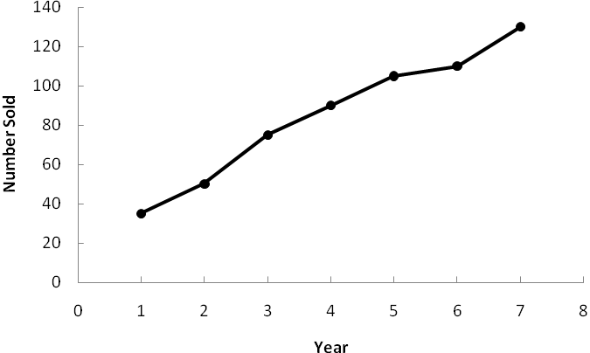

A linear trend pattern appears to be present in the time series plot.

b. A portion of the Minitab regression output follows.

The regression equation is

Number Sold = 22.9 + 15.5 Year

Predictor Coef SE Coef T P

Constant 22.857 4.503 5.08 0.004

Year 15.536 1.007 15.43 0.000

S = 5.32849 R-Sq = 97.9% R-Sq(adj) = 97.5%

Analysis of Variance

Source DF SS MS F P

Regression 1 6758.0 6758.0 238.02 0.000

Residual Error 5 142.0 28.4

Total 6 6900.0

c. Forecast in year 8 = 22.857 +15.536(8) = 147.15 or approximately 147 units.

53. a. A portion of the Minitab regression output follows.

The regression equation is

Sales = 0.036 + 4.91 Qtr1 + 14.5 Qtr2 + 9.11 Qtr3 + 0.971 t

Predictor Coef SE Coef T P

Constant 0.0357 0.8648 0.04 0.967

Qtr1 4.9129 0.8724 5.63 0.000

Qtr2 14.5134 0.8682 16.72 0.000

Qtr3 9.1138 0.8657 10.53 0.000

t 0.97098 0.03822 25.41 0.000

S = 1.61791 R-Sq = 97.5% R-Sq(adj) = 97.1%

Analysis of Variance

Source DF SS MS F P

Regression 4 2385.04 596.26 227.79 0.000

Residual Error 23 60.21 2.62

Total 27 2445.25

b. The quarterly forecast for next year correspond to *t* = 29, 30, 31, and 32.

Forecast for Quarter 1 (*t* = 29) = 0.0357 + 4.9129(1) + 14.5134(0) + 9.1138(0) + 0.971(29) = 33.1

Forecast for Quarter 2 (*t* = 30) = 0.0357 + 4.9129(0) + 14.5134(1) + 9.1138(0) + 0.971(30) = 43.7

Forecast for Quarter 3 (*t* = 31) = 0.0357 + 4.9129(0) + 14.5134(0) + 9.1138(1) + 0.971(31) = 39.3

Forecast for Quarter 4 (*t* = 32) = 0.0357 + 4.9129(0) + 14.5134(0) + 9.1138(0) + 0.971(32) = 31.1

54. a.

|  |  |  |
| --- | --- | --- |
| *t* | Sales | Centered  Moving Average |
| 1 | 6 |  |
| 2 | 15 |  |
| 3 | 10 | 9.250 |
| 4 | 4 | 10.125 |
| 5 | 10 | 11.125 |
| 6 | 18 | 12.125 |
| 7 | 15 | 13.000 |
| 8 | 7 | 14.500 |
| 9 | 14 | 16.500 |
| 10 | 26 | 18.125 |
| 11 | 23 | 19.375 |
| 12 | 12 | 20.250 |
| 13 | 19 | 20.750 |
| 14 | 28 | 21.750 |
| 15 | 25 | 22.875 |
| 16 | 18 | 24.000 |
| 17 | 22 | 25.125 |
| 18 | 34 | 25.875 |
| 19 | 28 | 26.500 |
| 20 | 21 | 27.000 |
| 21 | 24 | 27.500 |
| 22 | 36 | 27.625 |
| 23 | 30 | 28.000 |
| 24 | 20 | 29.000 |
| 25 | 28 | 30.125 |
| 26 | 40 | 31.625 |
| 27 | 35 |  |
| 28 | 27 |  |

b.

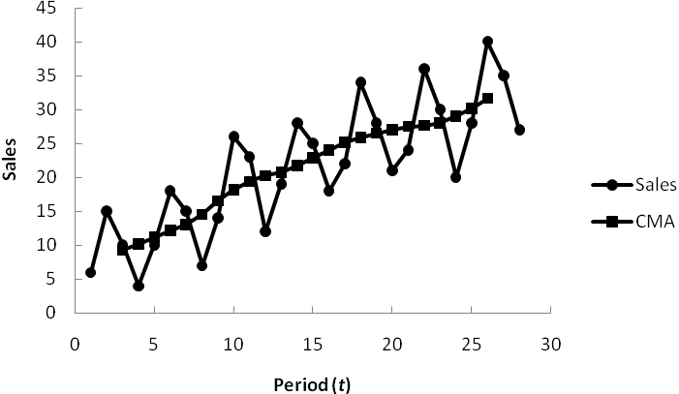

The centered moving average values smooth out the time series by removing seasonal effects and some of the random variability. The centered moving average time series shows the trend in the data.

c.

|  |  |  |  |
| --- | --- | --- | --- |
| *t* | Sales | Centered  Moving Average | Seasonal-Irregular Value |
| 1 | 6 |  |  |
| 2 | 15 |  |  |
| 3 | 10 | 9.250 | 1.081 |
| 4 | 4 | 10.125 | 0.395 |
| 5 | 10 | 11.125 | 0.899 |
| 6 | 18 | 12.125 | 1.485 |
| 7 | 15 | 13.000 | 1.154 |
| 8 | 7 | 14.500 | 0.483 |
| 9 | 14 | 16.500 | 0.848 |
| 10 | 26 | 18.125 | 1.434 |
| 11 | 23 | 19.375 | 1.187 |
| 12 | 12 | 20.250 | 0.593 |
| 13 | 19 | 20.750 | 0.916 |
| 14 | 28 | 21.750 | 1.287 |
| 15 | 25 | 22.875 | 1.093 |
| 16 | 18 | 24.000 | 0.750 |
| 17 | 22 | 25.125 | 0.876 |
| 18 | 34 | 25.875 | 1.314 |
| 19 | 28 | 26.500 | 1.057 |
| 20 | 21 | 27.000 | 0.778 |
| 21 | 24 | 27.500 | 0.873 |
| 22 | 36 | 27.625 | 1.303 |
| 23 | 30 | 28.000 | 1.071 |
| 24 | 20 | 29.000 | 0.690 |
| 25 | 28 | 30.125 | 0.929 |
| 26 | 40 | 31.625 | 1.265 |
| 27 | 35 |  |  |
| 28 | 27 |  |  |

|  |  |  |  |
| --- | --- | --- | --- |
| Quarter | Seasonal-Irregular  Component Values |  | Seasonal Index |
| 1 | 0.899, 0.848, 0.916, 0.876, 0.873, 0.929 |  | 0.890 |
| 2 | 1.485, 1.434, 1.287, 1.314, 1.303, 1.265 |  | 1.348 |
| 3 | 1.081, 1.154, 1.187, 1.093, 1.057, 1.071 |  | 1.107 |
| 4 | 0.395, 0.483, 0.593, 0.750, 0.778, 0.690 |  | 0.615 |
|  |  | Total | 3.960 |

|  |  |
| --- | --- |
| Quarter | Adjusted Seasonal Index |
| 1 | 0.899 |
| 2 | 1.362 |
| 3 | 1.118 |
| 4 | 0.621 |

Note: Adjustment for seasonal index = 4.00 / 3.96 = 1.0101

d. Hudson Marine experiences the largest seasonal increase in quarter 2. Since this quarter occurs prior to the peak summer boating season, this result seems reasonable. But the largest seasonal effect is the seasonal decrease in quarter 4. This is also reasonable because of decreased boating in the fall and winter.

55. a.

|  |  |  |  |  |
| --- | --- | --- | --- | --- |
| **Year** | **Quarter** | **Sales** | **Adjusted Seasonal Index** | **Deseasonalized Sales** |
| 1 | 1 | 6 | 0.899 | 6.673 |
|  | 2 | 15 | 1.362 | 11.016 |
|  | 3 | 10 | 1.118 | 8.942 |
|  | 4 | 4 | 0.621 | 6.443 |
| 2 | 1 | 10 | 0.899 | 11.122 |
|  | 2 | 18 | 1.362 | 13.219 |
|  | 3 | 15 | 1.118 | 13.413 |
|  | 4 | 7 | 0.621 | 11.275 |
| 3 | 1 | 14 | 0.899 | 15.571 |
|  | 2 | 26 | 1.362 | 19.094 |
|  | 3 | 23 | 1.118 | 20.566 |
|  | 4 | 12 | 0.621 | 19.328 |
| 4 | 1 | 19 | 0.899 | 21.132 |
|  | 2 | 28 | 1.362 | 20.563 |
|  | 3 | 25 | 1.118 | 22.355 |
|  | 4 | 18 | 0.621 | 28.993 |
| 5 | 1 | 22 | 0.899 | 24.468 |
|  | 2 | 34 | 1.362 | 24.969 |
|  | 3 | 28 | 1.118 | 25.037 |
|  | 4 | 21 | 0.621 | 33.825 |
| 6 | 1 | 24 | 0.899 | 26.692 |
|  | 2 | 36 | 1.362 | 26.438 |
|  | 3 | 30 | 1.118 | 26.825 |
|  | 4 | 20 | 0.621 | 32.214 |
| 7 | 1 | 28 | 0.899 | 31.141 |
|  | 2 | 40 | 1.362 | 29.376 |
|  | 3 | 35 | 1.118 | 31.296 |
|  | 4 | 27 | 0.621 | 43.489 |

A portion of the Minitab regression output for the deseasonalized sales time series follows.

The regression equation is

Deseasonalized Sales = 6.33 + 1.05 t

Predictor Coef SE Coef T P

Constant 6.332 1.195 5.30 0.000

t 1.05466 0.07203 14.64 0.000

S = 3.07863 R-Sq = 89.2% R-Sq(adj) = 88.8%

Analysis of Variance

Source DF SS MS F P

Regression 1 2032.2 2032.2 214.41 0.000

Residual Error 26 246.4 9.5

Total 27 2278.6

b. The quarterly forecast for next year correspond to *t* = 29, 30, 31, and 32.

Forecast for Quarter 1 (*t* = 29) = 6.332 + 1.055(29) = 36.93

Forecast for Quarter 2 (*t* = 30) = 6.332 + 1.055(30) = 37.98

Forecast for Quarter 3 (*t* = 31) = 6.332 + 1.055(31) = 39.04

Forecast for Quarter 4 (*t* = 32) = 6.332 + 1.055(32) = 40.09

c. Multiplying the quarterly trend forecasts by the adjusted seasonal indexes provides the forecasts for next year.

Forecast for Quarter 1 (*t* = 29) = 36.93(.899) = 33.2

Forecast for Quarter 2 (*t* = 30) = 37.98(1.362) = 51.7

Forecast for Quarter 3 (*t* = 31) = 39.04(1.118) = 43.65

Forecast for Quarter 4 (*t* = 32) = 40.09(.621) = 24.9